Project 2.1

*Project - Churn Prediction*

ABSTRACT

Customer value analysis is critical for a good marketing and a customer relationship management strategy. An important component of this strategy is the customer retention rate. Customer retention rate has a strong impact on the customer lifetime value, and understanding the true value of a possible customer churn will help the company in its customer relationship management. Conventional statistical methods are very successful in predicting a customer churn. The goal of this study is to apply logistic regression techniques to predict a customer churn and analyze the churning and no-churning customers by using data provided for the project

Introduction

The subject of customer retention, loyalty, and churn is receiving attention in many industries. This is important in the customer lifetime value context. A company will have a sense of how much is really being lost because of the customer churn and the scale of the efforts that would be appropriate for retention campaign. The mass marketing approach cannot succeed in the diversity of consumer business today. Customer value analysis along with customer churn predictions will help marketing programs target more specific groups of customers. Personal retail banking sector is characterized by customers who stays with a company very long time. Customers usually give their financial business to one company and they won’t switch the provider of their financial help very often. In the company’s perspective this produces a stable environment for the customer relationship management. Although the continuous relationships with the customers the potential loss of revenue because of customer churn in this case can be huge.

This paper will present a customer churn analysis for the data provided in the project 2. The goal of this paper is twofold. First the churning customers are analyzed in R – Logistic Regression model after applying appropriate preprocessing techniques . The second stage we need to connect with Tableau and R for visualization, probability and prediction in Tableau using the trained and testing set.

Logistic regression Binomial (binary) logistic regression is a form of regression which is used in a situation when dependent is not a continuous variable but a state which may or may not happen, or a category in a specific classification . Logistic regression can be used to predict a discrete outcome on the basis of continuous and/or categorical variables. Multinomial logistic regression exists to handle the case of dependents with more classes than two. In the logistic regression there can be only one dependent variable. Logistic regression applies maximum likelihood estimation after transforming the dependent into a logistic variable [8]. Unlike the normal regression model the dependent variable in logistic regression is usually dichotomous: the dependent variable can take value 1 with probability q and value 0 with probability 1-q.

Preprocessing

The Churn data provided for the project 2 is checked for the preprocessing requirements if any. Normally, the missing values requires creates many problems during analysis and this requires preprocessing and imputation etc., In this project the Amelia library is used to identify the missing values and as per the graph given below there is no missing value in the data.

**library**(Amelia)

## Loading required package: Rcpp

## ##

## ## Amelia II: Multiple Imputation

## ## (Version 1.7.5, built: 2018-05-07)

## ## Copyright (C) 2005-2018 James Honaker, Gary King and Matthew Blackwell ## ## Refer to <http://gking.harvard.edu/amelia/>for more information

## ##

**any**(**is.na**(Churn))

## [1] FALSE

*# visualize the missing values using the missing map from the Amelia package*

**missmap**(Churn,col=**c**("yellow","red"))

## Warning in if (class(obj) == "amelia") {: the condition has length > 1 and ## only the first element will be used

## Warning: Unknown or uninitialised column: 'arguments'.

## Warning: Unknown or uninitialised column: 'arguments'.

## Warning: Unknown or uninitialised column: 'imputations'.

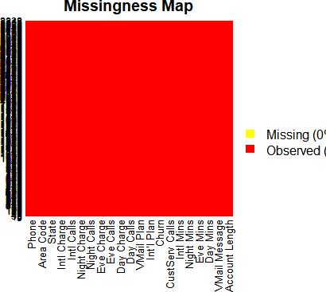

Excluding phone and state from the data set as they are not very important

|  |  |  |  |  |  |  |  |
| --- | --- | --- | --- | --- | --- | --- | --- |
| mydata2<-Churn[,**-**21] mydata<-mydata2[,**-**19]  **sapply**(mydata, **function**(x) **sum**(**is.na**(x))) | | | | | | | |
| ## | Account Length | VMail Message | Day Mins | Eve | Mins | Night | Mins |
| ## | 0 | 0 | 0 |  | 0 |  | 0 |
| ## | Intl Mins | CustServ Calls | Churn | Int'l | Plan | VMail | Plan |
| ## | 0 | 0 | 0 |  | 0 |  | 0 |
| ## | Day Calls | Day Charge | Eve Calls | Eve Charge | | Night Calls | |
| ## | 0 | 0 | 0 | 0 | | 0 | |

|  |  |  |  |  |  |  |  |
| --- | --- | --- | --- | --- | --- | --- | --- |
| ## ## | Night Charge  0 | | Intl Calls  0 | | Intl | Charge  0 | Area Code  0 |
| mydata <- mydata[**complete.cases**(mydata), ]  intrain<- **createDataPartition**(mydata**$**Churn,p=0.8,list=FALSE) **set.seed**(2017)  training<- mydata[intrain,] testing<- mydata[**-**intrain,] **dim**(training); **dim**(testing)  ## [1] 2667 19  ## [1] 666 19  **library** (data.table)  **library** (plyr)  **library** (stringr)  ##  ## Attaching package: 'stringr'  ## The following object is masked from 'package:strucchange': ##  ## boundary  LogModel <- **glm**(Churn **~** .,family=**binomial**(link="logit"),data=training)  **print**(**summary**(LogModel))  ##  ## Call:  ## glm(formula = Churn ~ ., family = binomial(link = "logit"), data = training) ##  ## Deviance Residuals: | | | | | | | |
| ## | Min | 1Q | Median | 3Q | | Max | |
| ##  ##  ## | -2.1332  Coeffici | -0.5222  ents: | -0.3425 | -0.1992 | | 3.2941 | |

## Estimate Std. Error z value Pr(>|z|)

## (Intercept) -7.420e+00 1.024e+00 -7.249 4.2e-13 ***

## `Account Length` 1.141e-03 1.533e-03 0.744 0.456828 ## `VMail Message` 4.207e-02 2.027e-02 2.075 0.037983 * ## `Day Mins` -1.341e+00 3.624e+00 -0.370 0.711274 ## `Eve Mins` -6.519e-01 1.813e+00 -0.360 0.719209 ## `Night Mins` -4.968e-01 9.739e-01 -0.510 0.610007 ## `Intl Mins` -7.267e-01 5.875e+00 -0.124 0.901560

## `CustServ Calls` 5.299e-01 4.387e-02 12.079 < 2e-16 *** ## `Int'l Plan` 2.096e+00 1.610e-01 13.022 < 2e-16 *** ## `VMail Plan` -2.319e+00 6.533e-01 -3.550 0.000385 *** ## `Day Calls` 2.586e-03 3.042e-03 0.850 0.395283

## `Day Charge` 7.962e+00 2.132e+01 0.373 0.708808 ## `Eve Calls` 8.044e-04 3.055e-03 0.263 0.792319 ## `Eve Charge` 7.744e+00 2.133e+01 0.363 0.716583 ## `Night Calls` -2.353e-03 3.160e-03 -0.745 0.456435 ## `Night Charge` 1.109e+01 2.164e+01 0.513 0.608260

## `Intl Calls` -1.044e-01 2.812e-02 -3.712 0.000206 *** ## `Intl Charge` 2.960e+00 2.176e+01 0.136 0.891786

## `Area Code` -6.509e-05 1.462e-03 -0.045 0.964500 ## ---

## Signif. codes: 0 '***' 0.001 '**' 0.01 '*' 0.05 '.' 0.1 ' ' 1 ##

## (Dispersion parameter for binomial family taken to be 1) ##

## Null deviance: 2230.1 on 2666 degrees of freedom ## Residual deviance: 1755.5 on 2648 degrees of freedom ## AIC: 1793.5

##

## Number of Fisher Scoring iterations: 6

**anova**(LogModel, test="Chisq")

## Analysis of Deviance Table ##

## Model: binomial, link: logit

##

## Response: Churn ##

## Terms added sequentially (first to last) ##

##

## Df Deviance Resid. Df Resid. Dev Pr(>Chi) ## NULL 2666 2230.1

## `Account Length` 1 1.550 2665 2228.6 0.2132053

## `VMail Message` 1 26.557 2664 2202.0 2.559e-07 ***

## `Day Mins` 1 92.031 2663 2110.0 < 2.2e-16 ***

## `Eve Mins` 1 17.926 2662 2092.1 2.297e-05 ***

## `Night Mins` 1 1.924 2661 2090.1 0.1654485

## `Intl Mins` 1 9.890 2660 2080.2 0.0016614 **

## `CustServ Calls` 1 130.903 2659 1949.3 < 2.2e-16 ***

## `Int'l Plan` 1 163.266 2658 1786.1 < 2.2e-16 ***

## `VMail Plan` 1 14.094 2657 1772.0 0.0001739 ***

## `Day Calls` 1 0.719 2656 1771.3 0.3966047

## `Day Charge` 1 0.051 2655 1771.2 0.8214162

## `Eve Calls` 1 0.017 2654 1771.2 0.8948703

## `Eve Charge` 1 0.132 2653 1771.1 0.7158769

## `Night Calls` 1 0.536 2652 1770.5 0.4641722

## `Night Charge` 1 0.190 2651 1770.3 0.6629360

## `Intl Calls` 1 14.804 2650 1755.5 0.0001193 ***

## `Intl Charge` 1 0.019 2649 1755.5 0.8911511

## `Area Code` 1 0.002 2648 1755.5 0.9644909 ## ---

## Signif. codes: 0 '***' 0.001 '**' 0.01 '*' 0.05 '.' 0.1 ' ' 1

testing**$**Churn <- **as.character**(testing**$**Churn) testing**$**Churn[testing**$**Churn**==**"No"] <- "0"

testing**$**Churn[testing**$**Churn**==**"Yes"] <- "1"

fitted.results <- **predict**(LogModel,newdata=testing,type='response') fitted.results

**sapply**(mydata, sd)

|  |  |  |  |  |  |
| --- | --- | --- | --- | --- | --- |
| ## | Account Length | VMail Message | Day Mins | Eve Mins | Night Mins |
| ## | 39.8221059 | 13.6883654 | 54.4673892 | 50.7138444 | 50.5738470 |
| ## | Intl Mins | CustServ Calls | Churn | Int'l Plan | VMail Plan |
| ## | 2.7918395 | 1.3154910 | 0.3520674 | 0.2958791 | 0.4473979 |
| ## | Day Calls | Day Charge | Eve Calls | Eve Charge | Night Calls |
| ## | 20.0690842 | 9.2594346 | 19.9226253 | 4.3106676 | 19.5686093 |
| ## | Night Charge | Intl Calls | Intl Charge | Area Code |  |
| ## | 2.2758728 | 2.4612143 | 0.7537726 | 42.3712905 |  |
| **plot.new**()  **plot**(mydata**$**Churn **~**mydata**$**`Day Mins`)  **title**('Basic Scatterplot') | | | | | |



**ggplot**(mydata, **aes**(x=mydata**$**`Day Mins`)) **+ geom_histogram**(binwidth = 1, fill = "white", color = "purple")

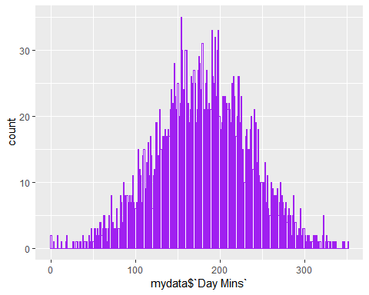

*#Randomly split data into train and test set*

*#80% will be ssigned to train set, 20% will be assigned to tst set*

**barplot**(**table**(mydata**$**Churn), col= **c**("green", "red"), main='bar plot of Churn')

**text**(**barplot**(**table**(mydata**$**Churn), col =**c**('green' , 'red'), main='bar plot of Churn'), 0,**table**(mydata**$**Churn)

, cex =2 , pos =3)

*#proportion*

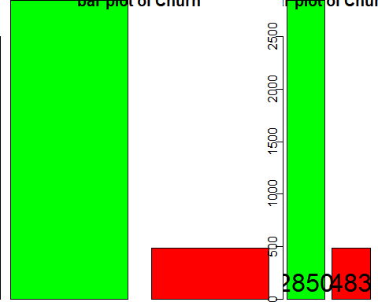

**round**(**prop.table**(**table**(mydata**$**Churn))**\***100,digits = 2)

##

## 0 1 (As per this churn is around 15%) ## 85.51 14.49

mydata_train<-mydata_n[1**:**2666,] mydata_test<-mydata_n[2667**:**3333,] mydata_train_labels<-mydata_n[1**:**2666,7] mydata_test_labels<-mydata_n[2667**:**3333,7]

**sapply**(mydata_n, sd)

## Account.Length VMail.Message Day.Mins Eve.Mins Night.Mins ## 0.1645542 0.2683993 0.1552662 0.1394387 0.1360243

## Intl.Mins CustServ.Calls Churn Int.l.Plan VMail.Plan ## 0.1395920 0.1461657 0.3520674 0.2958791 0.4473979

## Day.Calls Day.Charge Eve.Calls Eve.Charge Night.Calls ## 0.1216308 0.1552554 0.1171919 0.1394587 0.1378071

## Night.Charge Intl.Calls Intl.Charge ## 0.1360354 0.1230607 0.1395875

|  |  |  |  |  |  |  |
| --- | --- | --- | --- | --- | --- | --- |
| *#Forward elimination*  *#Lower AIC indicates a better model*  forward <- **step**(**glm**(Churn **~** 1, data = mydata_train), direction = 'forward', scope = **~**Account.Length**+**VMail.M essage**+**Day.Mins **+** Eve.Mins **+**  Night.Mins **+** Intl.Mins **+** CustServ.Calls **+** Int.l.Plan **+** VMail.Plan **+** Day.Calls **+** Day.Charge **+** Eve.Calls **+** Eve.Charge **+** Night.Calls **+** Night.Charge **+** Intl.Calls **+** Intl.Charge)  logit<- **glm**(Churn **~**Account.Length**+**Day.Mins**+** Day.Charge **+**CustServ.Calls**+**VMail.Plan **+**Eve.Mins**+** Eve.Charge**+**VMa il.Message**+**Day.Calls **+**Eve.Calls**+** Intl.Mins **+** Night.Calls**+**Intl.Calls, data = mydata_train, family = "binomia l")  **summary**(logit)  ##  ## Call:  ## glm(formula = Churn ~ Account.Length + Day.Mins + Day.Charge +  ## CustServ.Calls + VMail.Plan + Eve.Mins + Eve.Charge + VMail.Message + ## Day.Calls + Eve.Calls + Intl.Mins + Night.Calls + Intl.Calls,  ## family = "binomial", data = mydata_train) ##  ## Deviance Residuals: | | | | | |  |
| ##  ## ## ## ## | Min 1Q Median  -1.7136 -0.5583 -0.3989  Coefficients:  Estimate | 3Q  -0.2492  Std. Error | Max  3.0223  z value | Pr(>|z|) |  |  |
| ## | (Intercept) -7.4168 | 0.6846 | -10.834 | < 2e-16 | *** |  |
| ## | Account.Length 0.1336 | 0.3696 | 0.362 | 0.71771 |  |  |
| ## | Day.Mins 191.3463 | 1231.6229 | 0.155 | 0.87654 |  |  |
| ## | Day.Charge -187.0655 | 1231.7103 | -0.152 | 0.87929 |  |  |
| ## | CustServ.Calls 3.9702 | 0.3798 | 10.455 | < 2e-16 | *** |  |
| ## | VMail.Plan -1.7024 | 0.6098 | -2.792 | 0.00524 | ** |  |
| ## | Eve.Mins 462.5882 | 642.8816 | 0.720 | 0.47180 |  |  |
| ## | Eve.Charge -460.1275 | 642.7876 | -0.716 | 0.47410 |  |  |
| ## | VMail.Message 1.5122 | 0.9823 | 1.539 | 0.12371 |  |  |
| ## | Day.Calls 0.3629 | 0.4940 | 0.735 | 0.46264 |  |  |

|  |  |  |  |  |  |
| --- | --- | --- | --- | --- | --- |
| ## | Eve.Calls | 0.4090 0.5063 | 0.808 | 0.41921 |  |
| ## | Intl.Mins | 2.0353 0.4447 | 4.576 | 4.73e-06 | *** |
| ## | Night.Calls | 0.1657 0.4403 | 0.376 | 0.70665 |  |
| ## | Intl.Calls | -1.6524 0.5357 | -3.085 | 0.00204 | ** |
| ## | --- |  |  |  |  |
| ## | Signif. codes: | 0 '***' 0.001 '**' | 0.01 '*' | 0.05 '.' | 0.1 ' ' 1 |
| ## |  |  |  |  |  |
| ## (Dispersion parameter for binomial family taken to be 1)  ##  ## Null deviance: 2162.0 on 2665 degrees of freedom ## Residual deviance: 1867.4 on 2652 degrees of freedom ## AIC: 1895.4  ##  ## Number of Fisher Scoring iterations: 5 | | | | | |

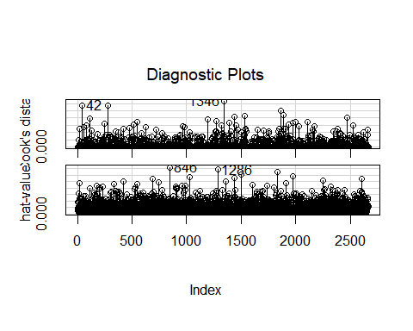

|  |  |  |  |
| --- | --- | --- | --- |
| *# Confidence interval using log-likelihood*  **confint**(logit)  ## Waiting for profiling to be done... | | | |
| ## |  | 2.5 % | 97.5 % |
| ## | (Intercept) | -8.7761881 | -6.0914407 |
| ## | Account.Length | -0.5919165 | 0.8578438 |
| ## | Day.Mins | -2224.7782913 | 2605.8924991 |
| ## | Day.Charge | -2601.7748293 | 2229.2388877 |
| ## | CustServ.Calls | 3.2299992 | 4.7198281 |
| ## | VMail.Plan | -2.9307458 | -0.5373346 |
| ## | Eve.Mins | -796.3103582 | 1725.2392867 |
| ## | Eve.Charge | -1722.5889512 | 798.5919581 |

|  |  |  |  |  |  |  |  |
| --- | --- | --- | --- | --- | --- | --- | --- |
| ## | VMail.Message | -0.4038228 | | 3.4527140 | | | |
| ## | Day.Calls | -0.6043867 | | 1.3330979 | | | |
| ## | Eve.Calls | -0.5823325 | | 1.4036271 | | | |
| ## | Intl.Mins | 1.1687246 | | 2.9129356 | | | |
| ## | Night.Calls | -0.6973052 | | 1.0293210 | | | |
| ## | Intl.Calls | -2.7201822 | | -0.6195282 | | | |
| **exp**(logit**$**coefficients) | | | | | | | |
| ## | (Intercept) | Account.Length | | Day.Mins | | Day.Charge | CustServ.Calls |
| ## | 6.010934e-04 | 1.142977e+00 | | 1.260826e+83 | | 5.734114e-82 | 5.299764e+01 |
| ## | VMail.Plan | Eve.Mins | | Eve.Charge | | VMail.Message | Day.Calls |
| ##  ##  ## | 1.822392e-01  Eve.Calls  1.505333e+00 | 7.933806e+200  Intl.Mins  7.654355e+00 | | 1.476321e-200  Night.Calls  1.180211e+00 | | 4.536688e+00  Intl.Calls  1.915949e-01 | 1.437439e+00 |
| *# logistic regression model:*  fit <- **glm**(Churn**~**.,data =mydata_train ,family = **binomial**(link='logit')) **summary**(fit)  ##  ## Call:  ## glm(formula = Churn ~ ., family = binomial(link = "logit"), data = mydata_train) ##  ## Deviance Residuals: | | | | | | | |
| ##  ## ## ##  ## | Min 1Q Median  -1.9680 -0.5111 -0.3376  Coefficients:  Estimate | | 3Q  -0.1979  Std. Error | | Max  3.1864  z value | Pr(>|z|) | |
| ## | (Intercept) -8.42021 | | 0.76774 | | -10.967 | < 2e-16 *** | |
| ## | Account.Length 0.01841 | | 0.38853 | | 0.047 | 0.962208 | |
| ## | VMail.Message 1.53996 | | 1.01473 | | 1.518 | 0.129114 | |
| ## | Day.Mins 213.42834 | | 1293.28315 | | 0.165 | 0.868922 | |
| ## | Eve.Mins 592.02181 | | 674.48943 | | 0.878 | 0.380088 | |
| ## | Night.Mins -110.40724 | | 368.95516 | | -0.299 | 0.764755 | |
| ## | Intl.Mins -287.85749 | | 120.73173 | | -2.384 | 0.017113 * | |

|  |  |  |  |  |  |
| --- | --- | --- | --- | --- | --- |
| ## CustServ.Calls 4.51834 0.40343 11.200 < 2e-16 ***  ## Int.l.Plan 2.06924 0.16257 12.729 < 2e-16 ***  ## VMail.Plan -1.87056 0.63215 -2.959 0.003086 **  ## Day.Calls 0.44168 0.51623 0.856 0.392222  ## Day.Charge -209.05873 1293.37170 -0.162 0.871590  ## Eve.Calls 0.43463 0.53648 0.810 0.417852  ## Eve.Charge -589.41466 674.38935 -0.874 0.382120  ## Night.Calls 0.01869 0.46116 0.041 0.967668  ## Night.Charge 111.62067 368.91878 0.303 0.762224  ## Intl.Calls -1.92925 0.56673 -3.404 0.000664 ***  ## Intl.Charge 289.76049 120.71956 2.400 0.016383 * ## ---  ## Signif. codes: 0 '***' 0.001 '**' 0.01 '*' 0.05 '.' 0.1 ' ' 1 ##  ## (Dispersion parameter for binomial family taken to be 1) ##  ## Null deviance: 2162.0 on 2665 degrees of freedom ## Residual deviance: 1702.5 on 2648 degrees of freedom ## AIC: 1738.5  ##  ## Number of Fisher Scoring iterations: 6  **library**(MASS)  step_fit <- **stepAIC**(fit,method='backward') **summary**(step_fit)  ##  ## Call:  ## glm(formula = Churn ~ VMail.Message + Day.Mins + Eve.Mins + Intl.Mins + ## CustServ.Calls + Int.l.Plan + VMail.Plan + Night.Charge +  ## Intl.Calls + Intl.Charge, family = binomial(link = "logit"), ## data = mydata_train)  ##  ## Deviance Residuals: | | | | | |
| ## | Min | 1Q | Median | 3Q | Max |
| ## | -1.9778 | -0.5124 | -0.3392 | -0.2020 | 3.1476 |

|  |  |  |  |  |  |  |  |  |
| --- | --- | --- | --- | --- | --- | --- | --- | --- |
| ## ## ## | Coefficients: | Estimate Std. Error | | z value | Pr(>|z|) |  |  | |
| ## | (Intercept) | -7.8769 0.5686 | | -13.853 | < 2e-16 | *** |
| ## | VMail.Message | 1.5052 1.0120 | | 1.487 | 0.136929 |  |
| ## | Day.Mins | 4.4084 0.4297 | | 10.259 | < 2e-16 | *** |
| ## | Eve.Mins | 2.5099 0.4622 | | 5.430 | 5.64e-08 | *** |
| ## | Intl.Mins | -291.5210 120.5655 | | -2.418 | 0.015608 | * |
| ## | CustServ.Calls | 4.5206 0.4022 | | 11.240 | < 2e-16 | *** |
| ## | Int.l.Plan | 2.0630 0.1622 | | 12.721 | < 2e-16 | *** |
| ## | VMail.Plan | -1.8555 0.6300 | | -2.945 | 0.003230 | ** |
| ## | Night.Charge | 1.2494 0.4652 | | 2.686 | 0.007235 | ** |
| ## | Intl.Calls | -1.9404 0.5652 | | -3.433 | 0.000596 | *** |
| ##  ##  ## | Intl.Charge  ---  Signif. codes: | 293.4337 120.5539  0 '***' 0.001 '**' | | 2.434  0.01 '*' | 0.014931  0.05 '.' | *  0.1 | ' ' | 1 |
| ## |  |  | |  |  |  |  |  |
| ## (Dispersion parameter for binomial family taken to be 1)  ##  ## Null deviance: 2162.0 on 2665 degrees of freedom ## Residual deviance: 1704.9 on 2655 degrees of freedom ## AIC: 1726.9  ##  ## Number of Fisher Scoring iterations: 6  **confint**(step_fit)  ## Waiting for profiling to be done... | | | | | | |  | |
| ## |  | 2.5 % | 97.5 % | | | | | |
| ## | (Intercept) | -9.0107622 | -6.7808248 | | | | | |
| ## | VMail.Message | -0.4650469 | 3.5078770 | | | | | |
| ## | Day.Mins | 3.5752571 | 5.2606938 | | | | | |
| ## | Eve.Mins | 1.6088317 | 3.4218238 | | | | | |
| ## | Intl.Mins | -528.7346134 | -55.8150001 | | | | | |
| ## | CustServ.Calls | 3.7372142 | 5.3151528 | | | | | |
| ## | Int.l.Plan | 1.7458847 | 2.3822001 | | | | | |

## VMail.Plan -3.1260647 -0.6530832

## Night.Charge 0.3391697 2.1636548

## Intl.Calls -3.0675068 -0.8511819

## Intl.Charge 57.7541777 530.6286565

*#ANOVA on base model*

**anova**(fit,test = 'Chisq')

## Analysis of Deviance Table ##

## Model: binomial, link: logit ##

## Response: Churn ##

## Terms added sequentially (first to last) ##

##

## Df Deviance Resid. Df Resid. Dev Pr(>Chi)

|  |  |  |  |  |  |  |  |
| --- | --- | --- | --- | --- | --- | --- | --- |
| ## | NULL |  |  | 2665 | 2162.0 |  |  |
| ## | Account.Length | 1 | 0.277 | 2664 | 2161.8 | 0.5985480 |
| ## | VMail.Message | 1 | 19.675 | 2663 | 2142.1 | 9.180e-06 | *** |
| ## | Day.Mins | 1 | 103.623 | 2662 | 2038.5 | < 2.2e-16 | *** |
| ## | Eve.Mins | 1 | 23.581 | 2661 | 2014.9 | 1.197e-06 | *** |
| ## | Night.Mins | 1 | 3.199 | 2660 | 2011.7 | 0.0736818 | . |
| ## | Intl.Mins | 1 | 17.379 | 2659 | 1994.3 | 3.062e-05 | *** |
| ## | CustServ.Calls | 1 | 111.293 | 2658 | 1883.0 | < 2.2e-16 | *** |
| ## | Int.l.Plan | 1 | 152.056 | 2657 | 1730.9 | < 2.2e-16 | *** |
| ## | VMail.Plan | 1 | 8.313 | 2656 | 1722.6 | 0.0039361 | ** |
| ## | Day.Calls | 1 | 1.004 | 2655 | 1721.6 | 0.3164303 |  |
| ## | Day.Charge | 1 | 0.101 | 2654 | 1721.5 | 0.7509001 |  |
| ## | Eve.Calls | 1 | 0.705 | 2653 | 1720.8 | 0.4010942 |  |
| ## | Eve.Charge | 1 | 0.752 | 2652 | 1720.1 | 0.3857120 |  |
| ## | Night.Calls | 1 | 0.000 | 2651 | 1720.1 | 0.9948372 |  |
| ## | Night.Charge | 1 | 0.088 | 2650 | 1720.0 | 0.7668220 |  |
| ## | Intl.Calls | 1 | 11.638 | 2649 | 1708.3 | 0.0006464 | *** |
| ## | Intl.Charge | 1 | 5.795 | 2648 | 1702.5 | 0.0160706 | * |

## ---

pred <- **predict**(fit,newdata = mydata_test,type ='response')

*#check the AUC curve*

**library**(pROC)

g <- **roc**( Churn**~** pred, data = mydata_test) g

##

## Call:

## roc.formula(formula = Churn ~ pred, data = mydata_test) ##

## Data: pred in 558 controls (Churn 0) < 109 cases (Churn 1). ## Area under the curve: 0.8266

**plot**(g)

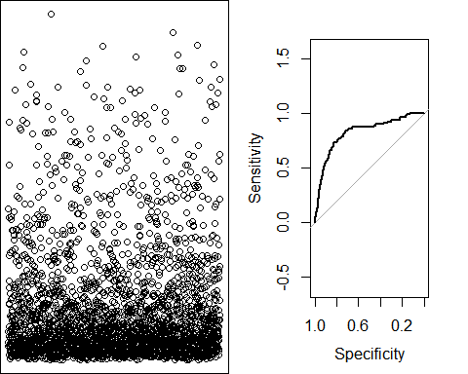

**library**(caret)

*#with default prob cut 0.50*

mydata_test**$**pred_Churn <- **ifelse**(pred**<**0.8,'yes','no')

**table**(mydata_test**$**pred_Churn,mydata_test**$**Churn)

##

## 0 1

## no 1 3

## yes 557 106

*#training split of churn classes*

**round**(**table**(mydata_train**$**Churn)**/nrow**(mydata_train),2)**\***100

##

## 0 1

## 86 14

*# test split of churn classes*

**round**(**table**(mydata_test**$**Churn)**/nrow**(mydata_test),2)**\***100

##

## 0 1

## 84 16

*#predicted split of churn classes*

**round**(**table**(mydata_test**$**pred_Churn)**/nrow**(mydata_test),2)**\***100

##

## no yes ## 1 99

*#create confusion matrix #confusionMatrix(mydata_test$Churn,mydata_test$pred_Churn) #how do we create a cross validation scheme*

control <- **trainControl**(method = 'repeatedcv',

number = 10,

repeats = 3)

seed <-7

metric <- 'Accuracy'

**set.seed**(seed)

fit_default <- **train**(Churn**~**.,

data = mydata_train, method = 'glm', metric = NaN, trControl = control)

## Warning in train.default(x, y, weights = w, ...): You are trying to do

## regression and your outcome only has two possible values Are you trying to ## do classification? If so, use a 2 level factor as your outcome column.

## Warning in train.default(x, y, weights = w, ...): The metric "NaN" was not ## in the result set. RMSE will be used instead.

**print**(fit_default)

## Generalized Linear Model ##

## 2666 samples

## 17 predictor ##

## No pre-processing

## Resampling: Cross-Validated (10 fold, repeated 3 times)

## Summary of sample sizes: 2399, 2400, 2399, 2399, 2400, 2399, ... ## Resampling results:

##

## RMSE Rsquared MAE

## 0.3171573 0.1668586 0.2165651

**library**(caret) **varImp**(step_fit)

## Overall

## VMail.Message 1.487325

## Day.Mins 10.258636

## Eve.Mins 5.429922

## Intl.Mins 2.417948

## CustServ.Calls 11.239954

## Int.l.Plan 12.720766

## VMail.Plan 2.945000

## Night.Charge 2.685836

## Intl.Calls 3.433245

## Intl.Charge 2.434045

**varImp**(fit_default)

## glm variable importance ##

|  |  |  |  |  |  |  |  |
| --- | --- | --- | --- | --- | --- | --- | --- |
| ## |  | | Overall | | | | |
| ## | Int.l.Plan | | 100.00000 | | | | |
| ## | CustServ.Calls | | 79.36943 | | | | |
| ## | Intl.Calls | | 21.54437 | | | | |
| ## | VMail.Plan | | 17.99874 | | | | |
| ## | Intl.Charge | | 15.22120 | | | | |
| ## | Intl.Mins | | 15.11822 | | | | |
| ## | VMail.Message | | 6.87083 | | | | |
| ## | Day.Calls | | 5.43601 | | | | |
| ## | Eve.Mins | | 5.43158 | | | | |
| ## | Eve.Charge | | 5.40848 | | | | |
| ## | Eve.Calls | | 4.87659 | | | | |
| ## | Night.Charge | | 3.45603 | | | | |
| ## | Night.Mins | | 3.43761 | | | | |
| ## | Day.Mins | | 1.44730 | | | | |
| ## | Day.Charge | | 1.42506 | | | | |
| ## | Account.Length | | 0.02108 | | | | |
| ## | Night.Calls | | 0.00000 | | | | |
| **library**(devtools) **library**(woe)  **library**(riv)  iv_df <- **iv.mult**(mydata_train, y="Churn", summary=TRUE, verbose=TRUE) iv_df | | | | | | | |
| ## |  | Variable | | InformationValue | Bins | ZeroBins | Strength |
| ## | 1 | Day.Charge | | 0.643151413 | 6 | 0 | Very strong |
| ## | 2 | Day.Mins | | 0.643151413 | 6 | 0 | Very strong |
| ## | 3 | CustServ.Calls | | 0.158681659 | 2 | 0 | Average |
| ## | 4 | Eve.Mins | | 0.149576165 | 5 | 0 | Average |
| ## | 5 | Eve.Charge | | 0.149310982 | 5 | 0 | Average |
| ## | 6 | Intl.Charge | | 0.097357797 | 4 | 0 | Weak |
| ## | 7 | Intl.Mins | | 0.097357797 | 4 | 0 | Weak |
| ## | 8 | VMail.Message | | 0.081622650 | 2 | 0 | Weak |

|  |  |  |  |  |  |  |  |
| --- | --- | --- | --- | --- | --- | --- | --- |
| ## | 9 | VMail.Plan | 0.081622650 | 2 | 0 |  | Weak |
| ## | 10 | Intl.Calls | 0.068633851 | 2 | 0 |  | Weak |
| ## | 11 | Night.Charge | 0.060709508 | 6 | 0 |  | Weak |
| ## | 12 | Account.Length | 0.033794008 | 4 | 0 |  | Weak |
| ## | 13 | Day.Calls | 0.028673937 | 3 | 0 |  | Weak |
| ## | 14 | Night.Mins | 0.022784889 | 2 | 0 |  | Weak |
| ## | 15 | Eve.Calls | 0.010611328 | 2 | 0 | Wery | weak |
| ## | 16 | Night.Calls | 0.009978104 | 2 | 0 | Wery | weak |
| ## | 17 | Int.l.Plan | 0.000000000 | 1 | 0 | Wery | weak |
| iv <- **iv.mult**(mydata_train, y="Churn", summary=FALSE, verbose=TRUE)  *# Plot information value summary* | | | | | | | |

TABALEAU VISUALIZATION

Library(Rserve) Rserve()

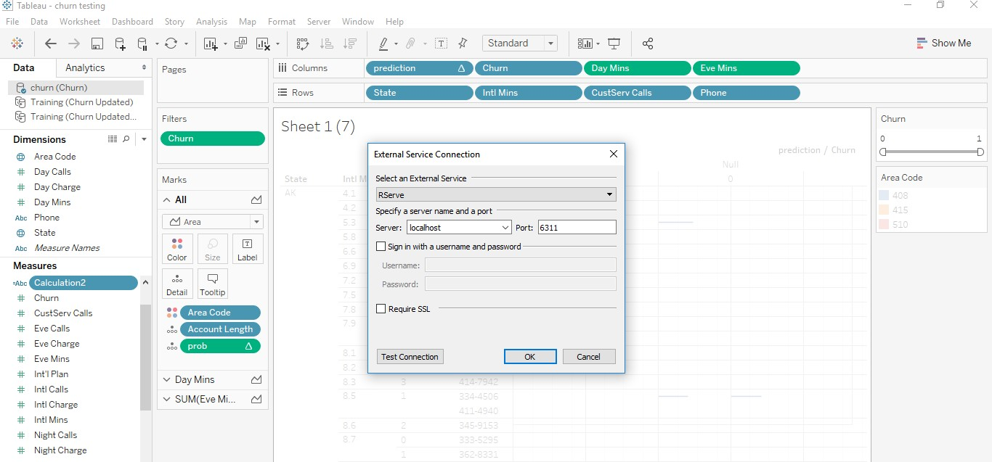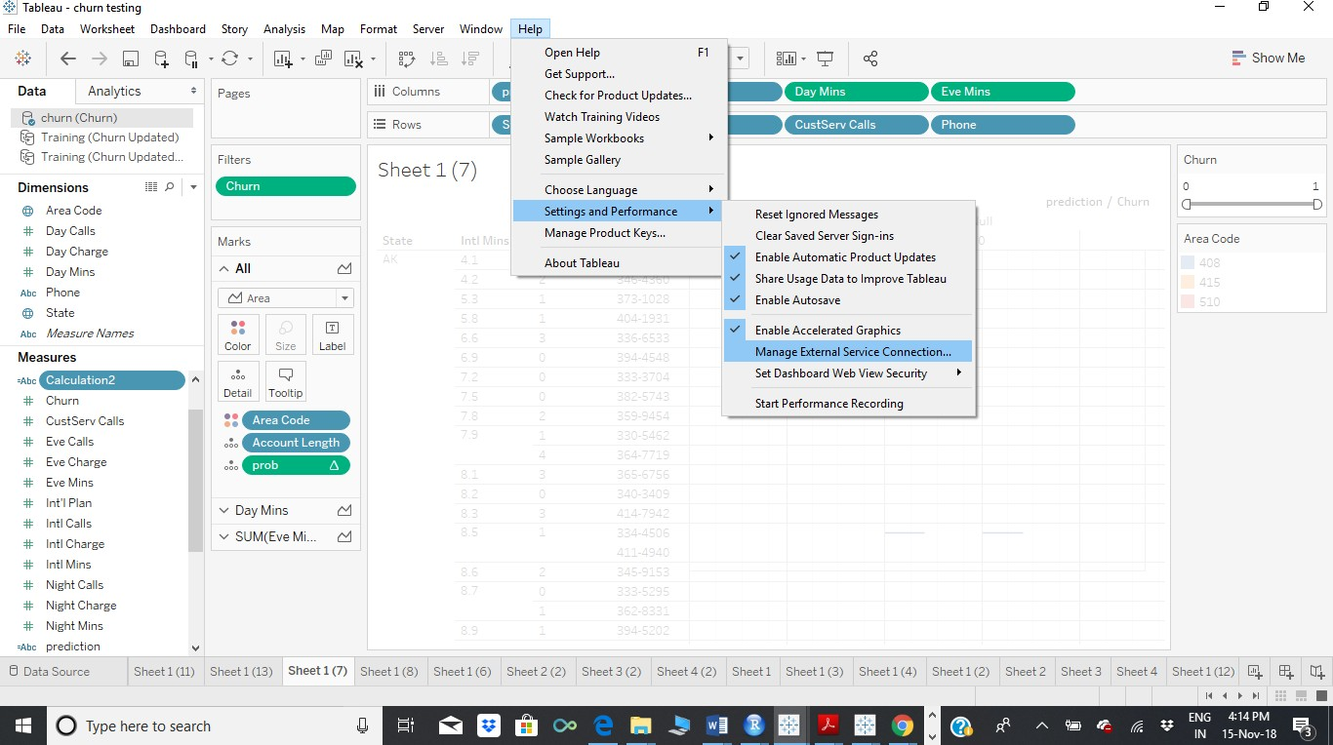

)

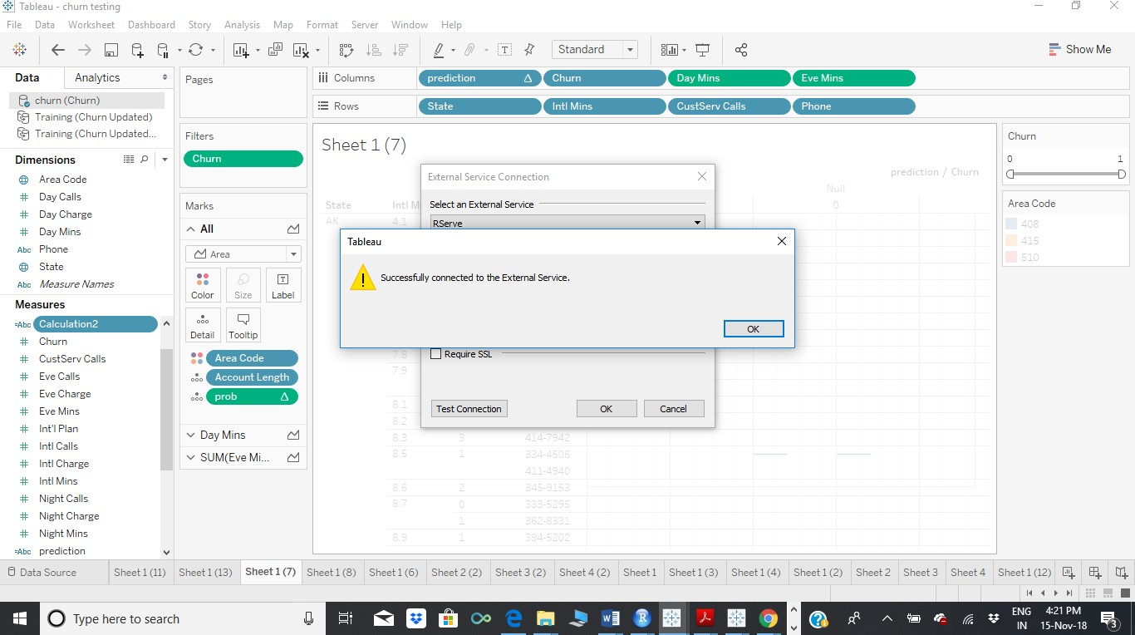

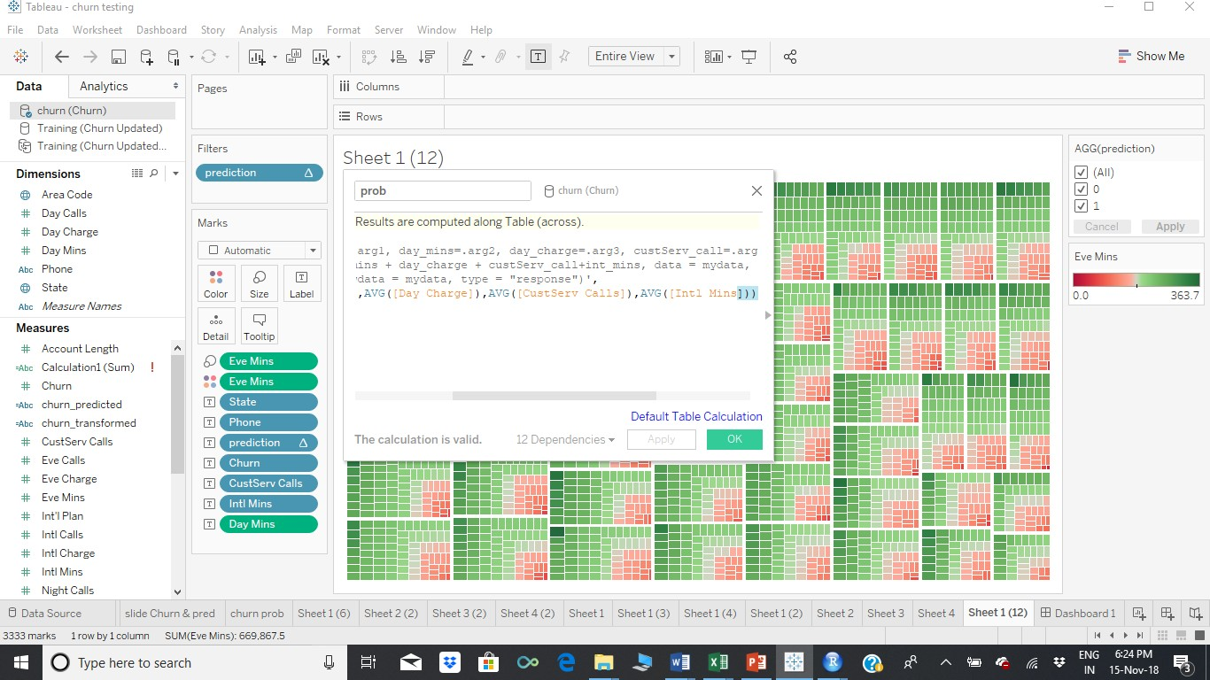

Calculated field (prob) SCRIPT_REAL('library(dplyr);

mydata <- data.frame(churn=.arg1, day_mins=.arg2, day_charge=.arg3, custServ_call=.arg4, int_mins=.arg5);

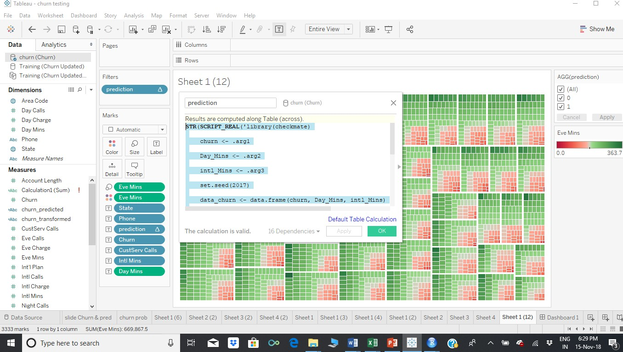

lrmodel <- glm(churn ~ day_mins + day_charge + custServ_call+int_mins, data = mydata, family = "binomial"); prob <- predict(lrmodel, newdata = mydata, type = "response")',

AVG([Churn]),AVG([Day Mins]),AVG([Day Charge]),AVG([CustServ Calls]),AVG([Intl Mins]))

STR(SCRIPT_REAL('library(checkmate)

churn <- .arg1 Day_Mins <- .arg2 intl_Mins <- .arg3 set.seed(2017)

data_churn <- data.frame(churn, Day_Mins, intl_Mins) intrain<-sample(1:nrow(data_churn),.7*nrow(data_churn)) training<- data_churn[intrain,]

testing<- data_churn[-intrain,] new_data<-rbind(training,testing)

LogModel <- glm(churn ~ .,family=binomial(link="logit"),data=training) fitted.results <- predict(LogModel,newdata=new_data,type="response") pred_val <- ifelse(fitted.results > 0.5,1,0)

pred_val

',ATTR([Churn]),SUM([Day Mins]),sum([Intl Mins])))

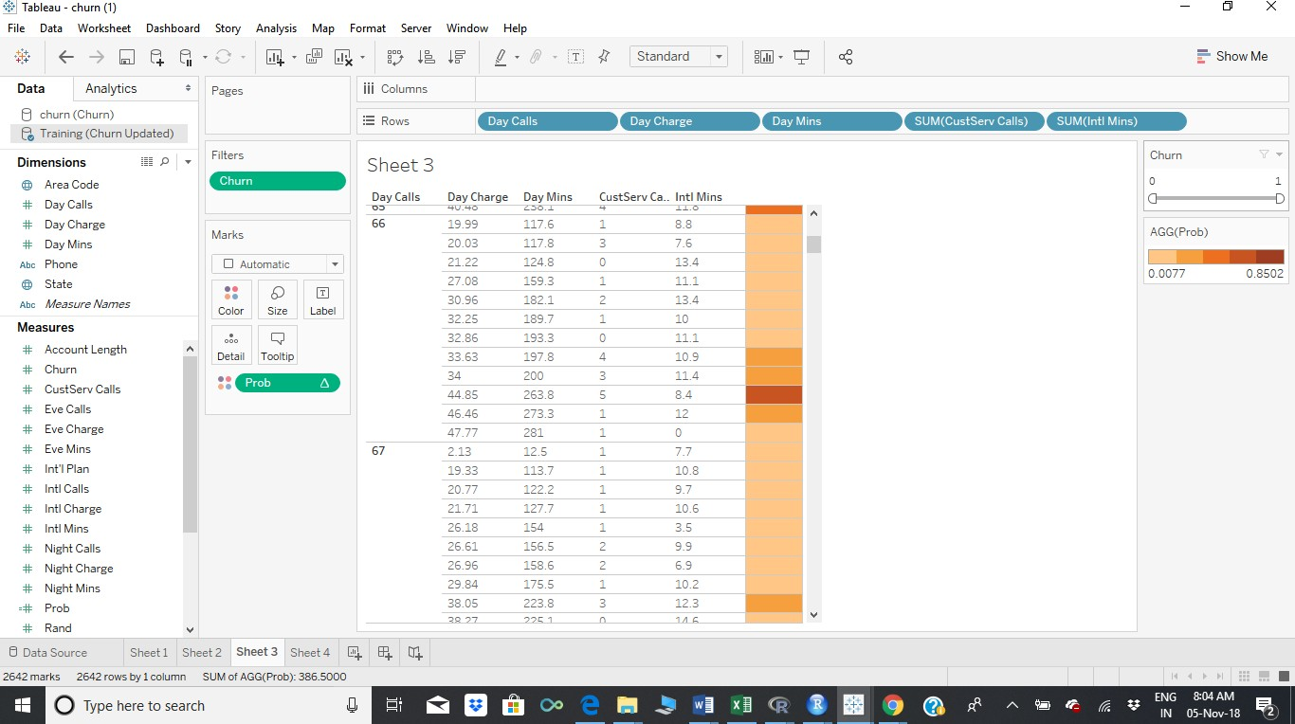

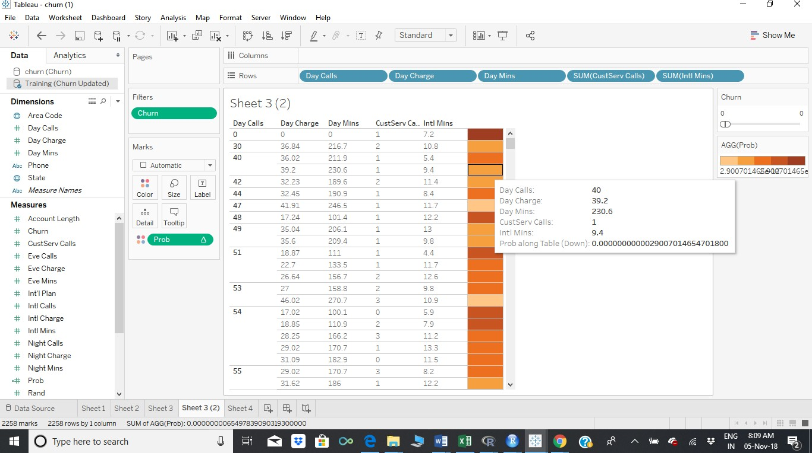

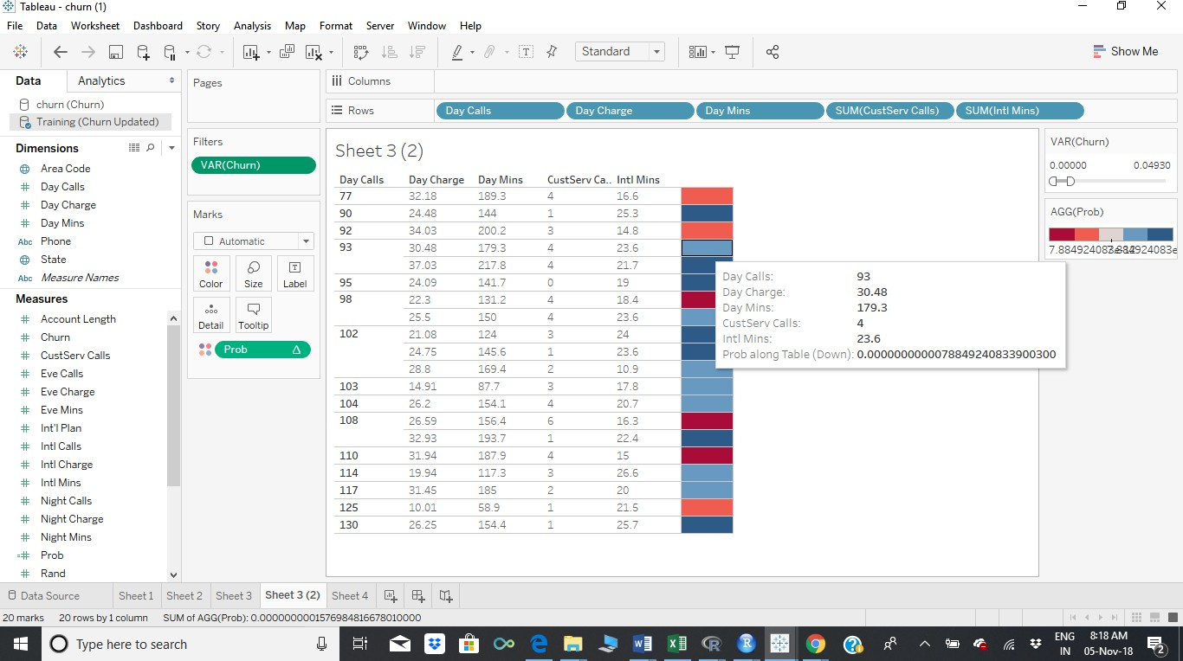

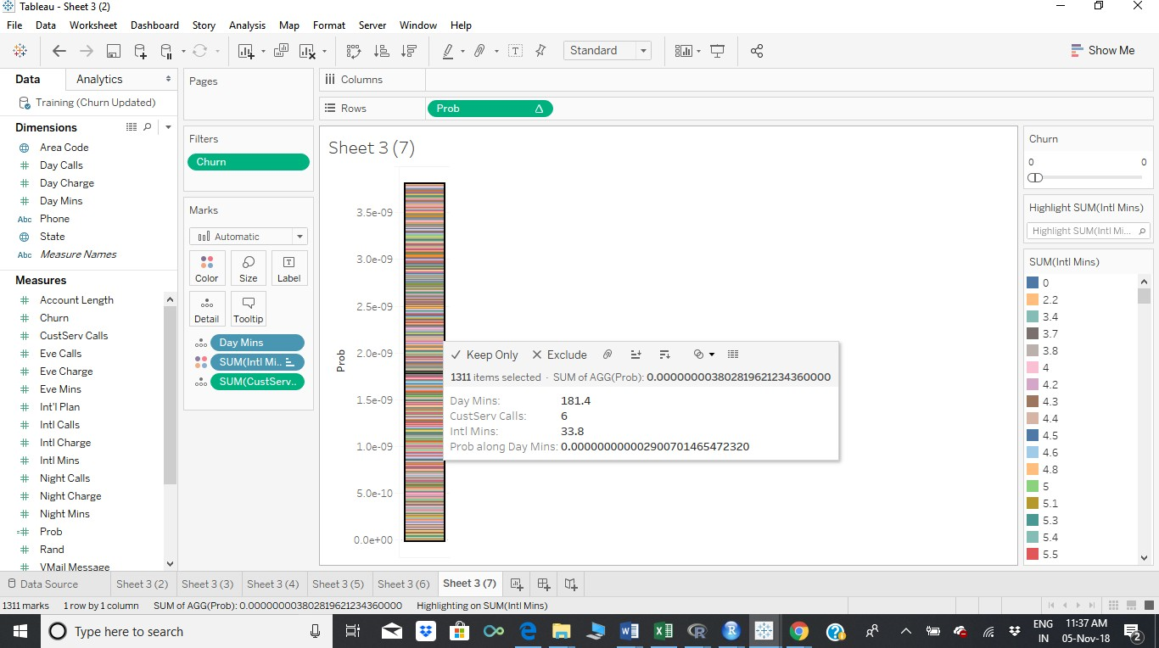

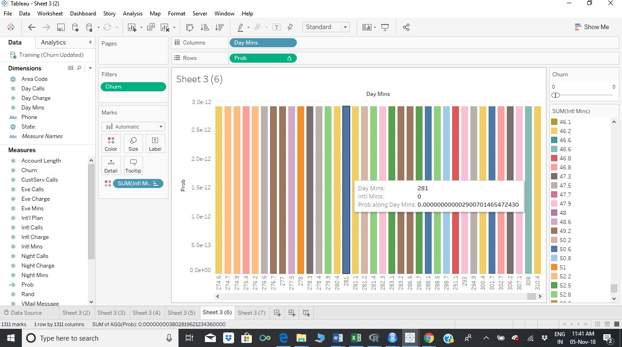

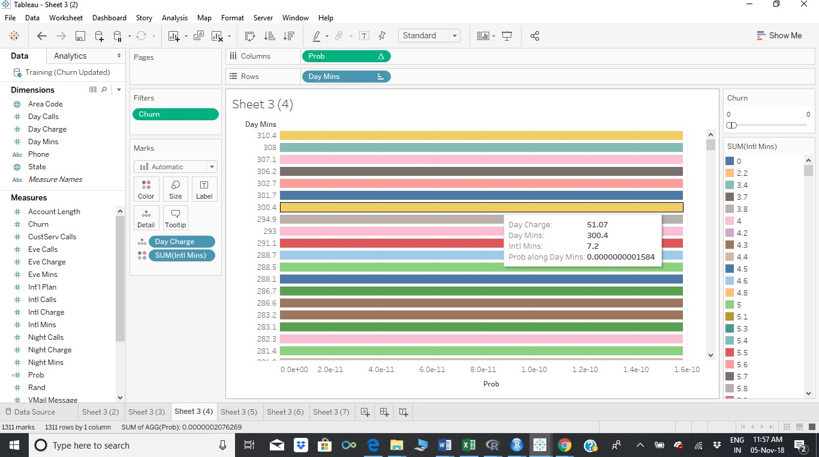

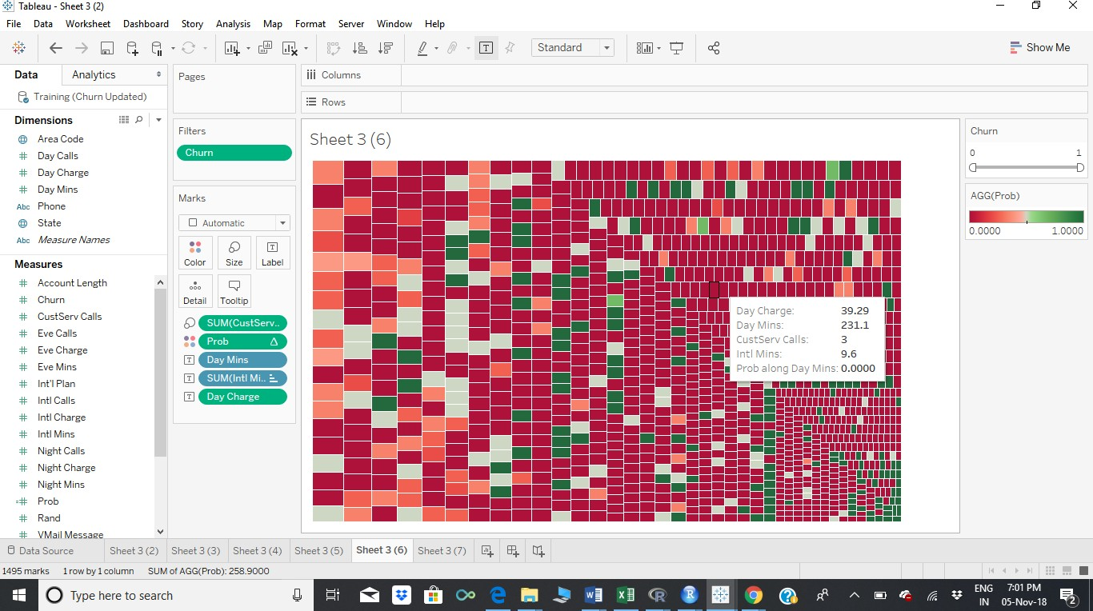

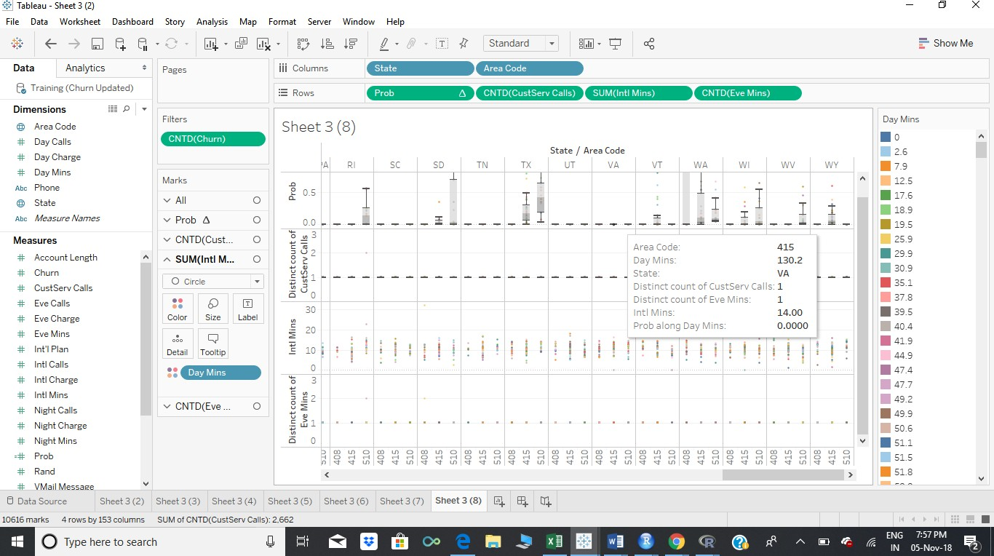

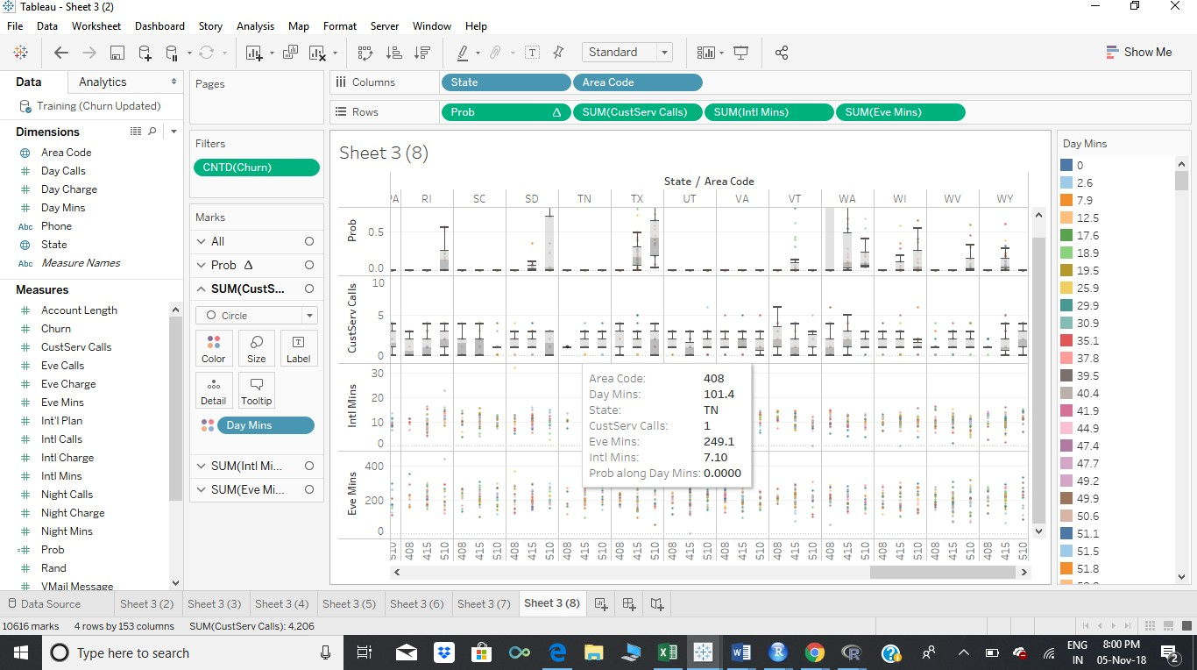

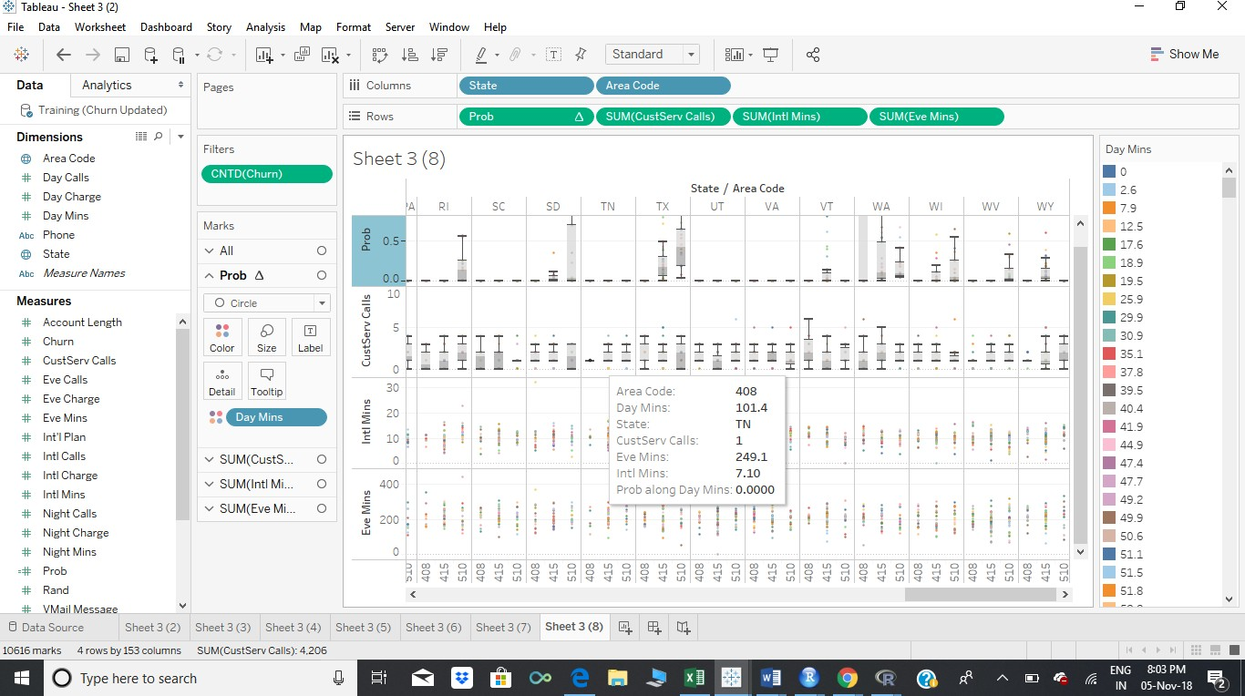

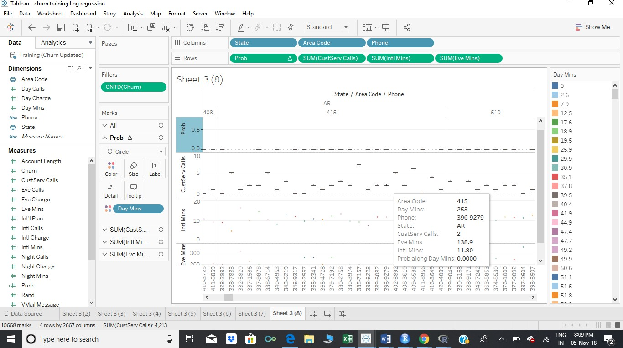

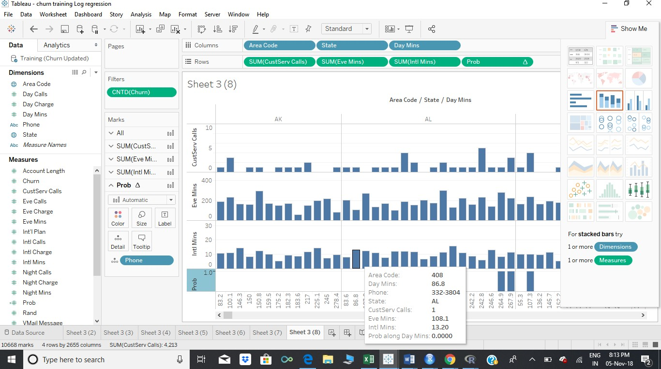

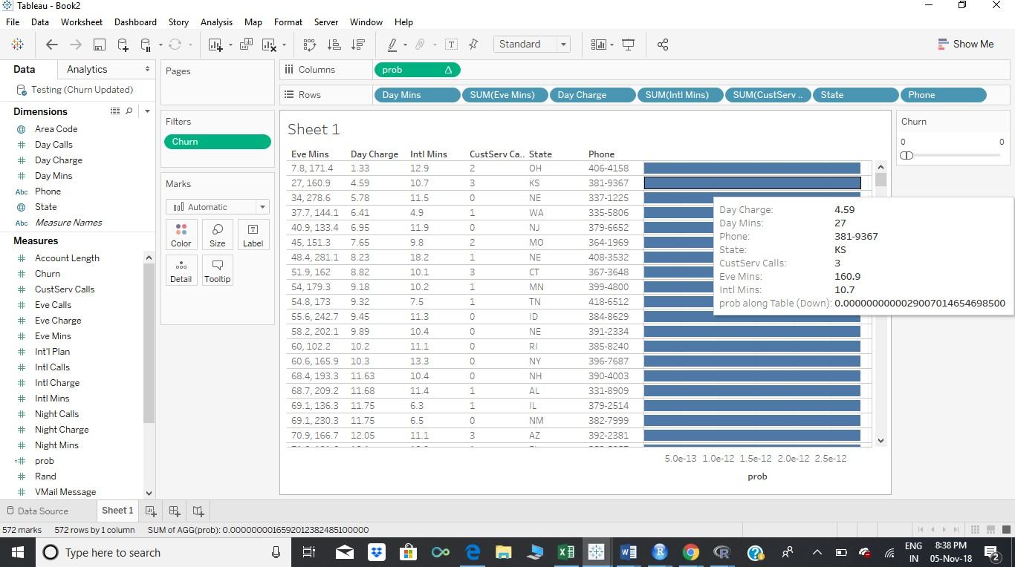

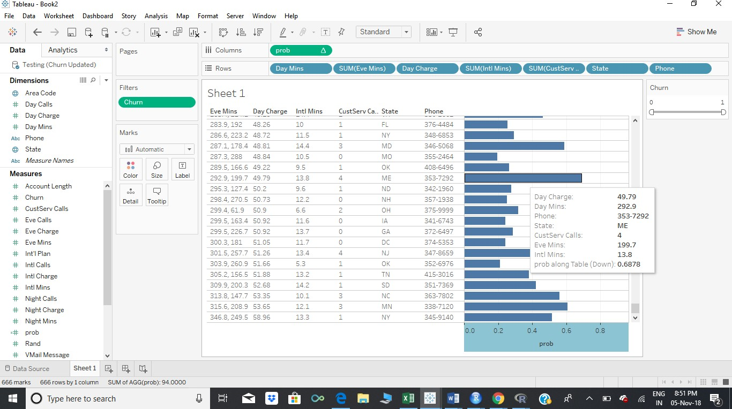

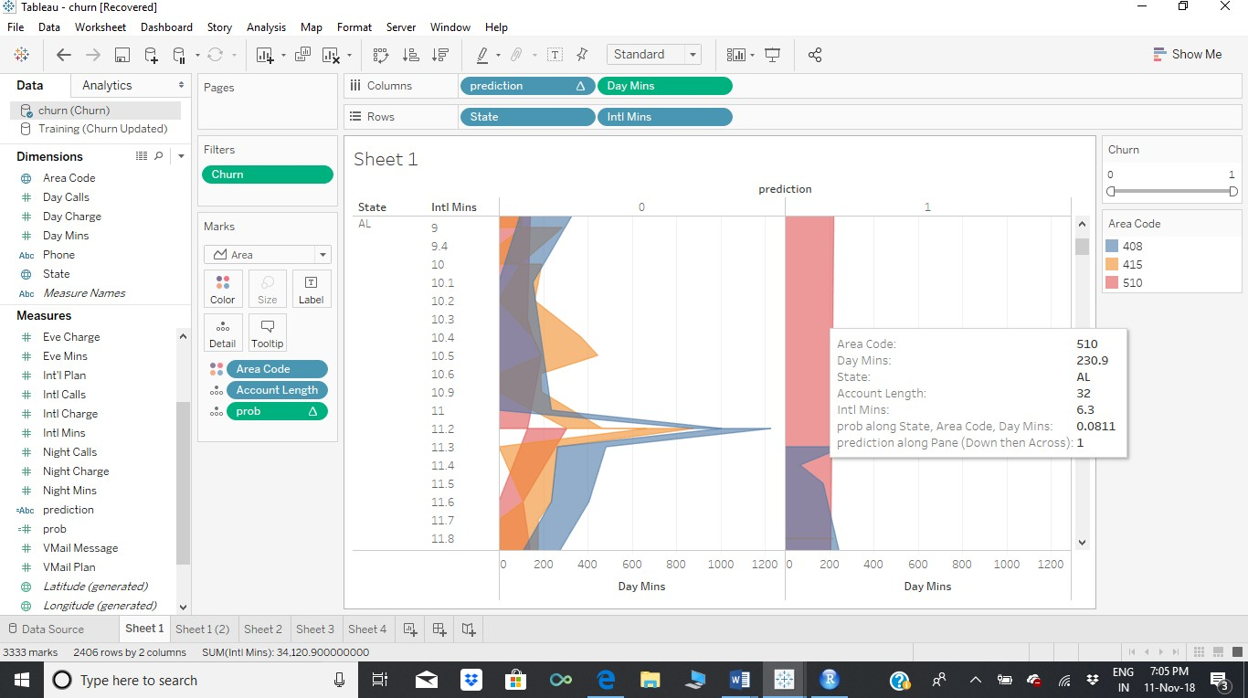

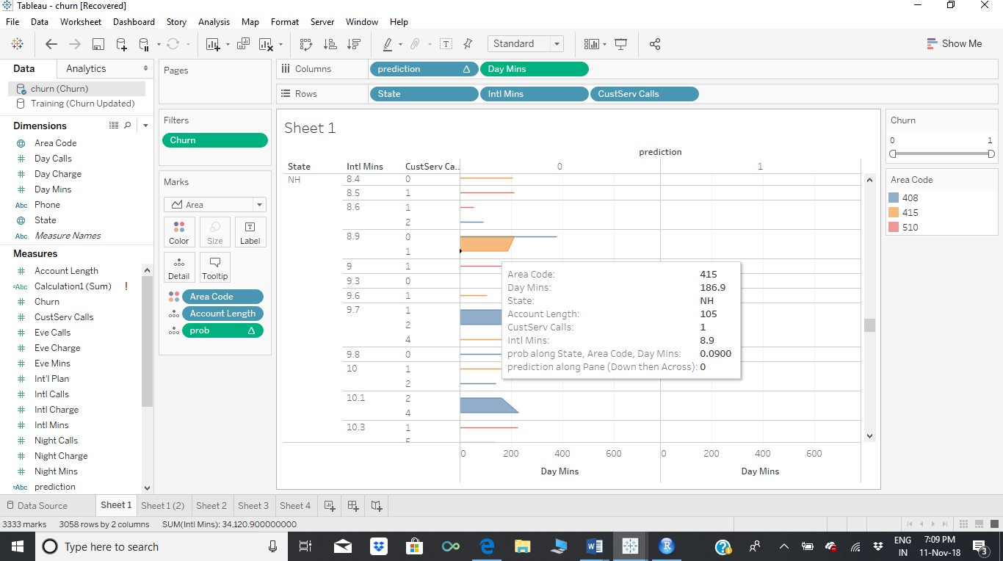

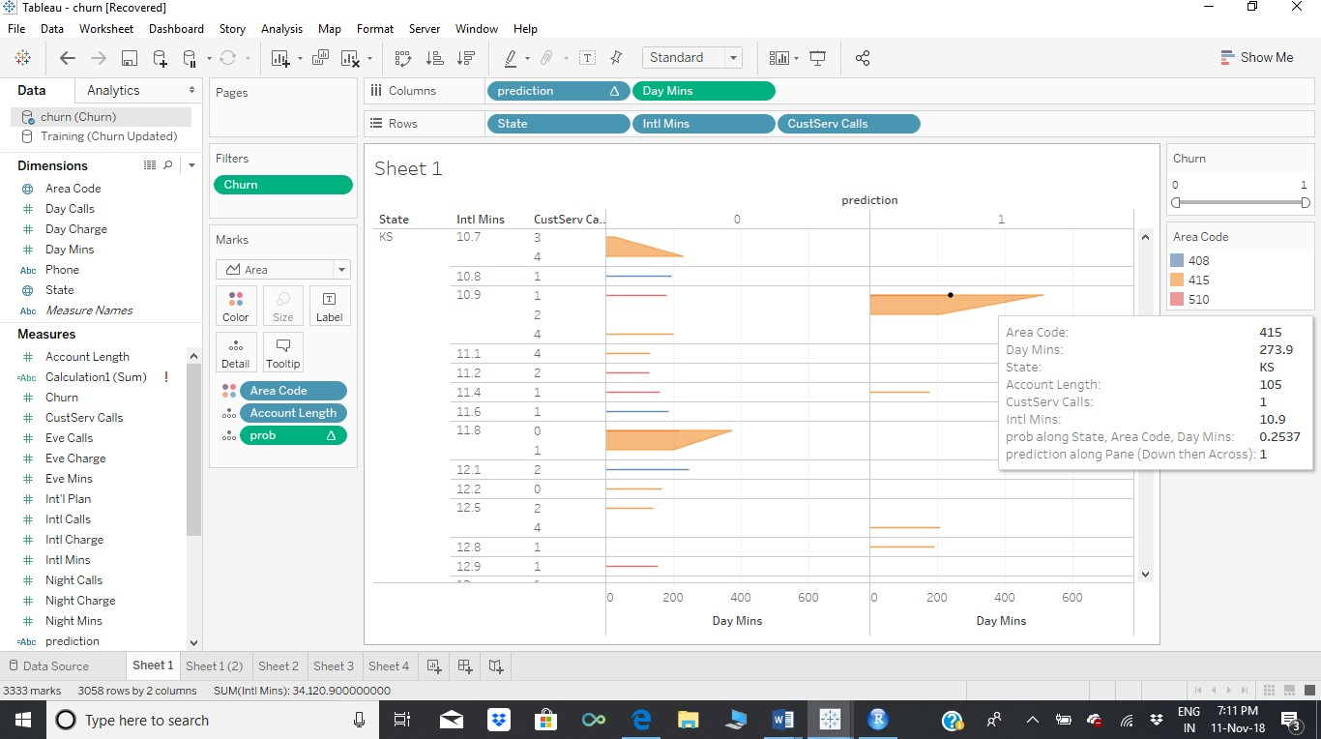

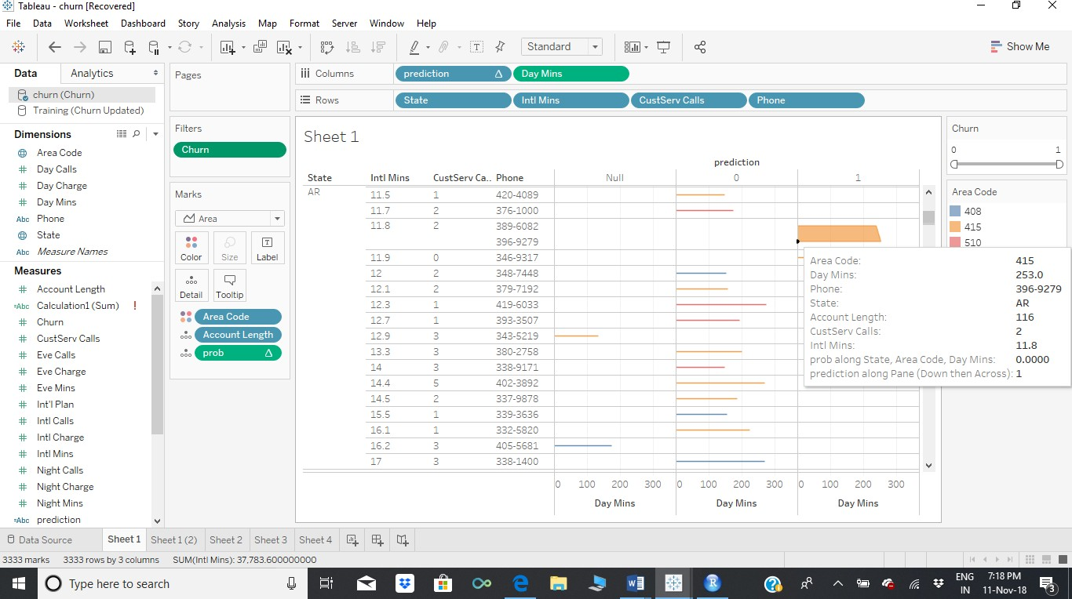

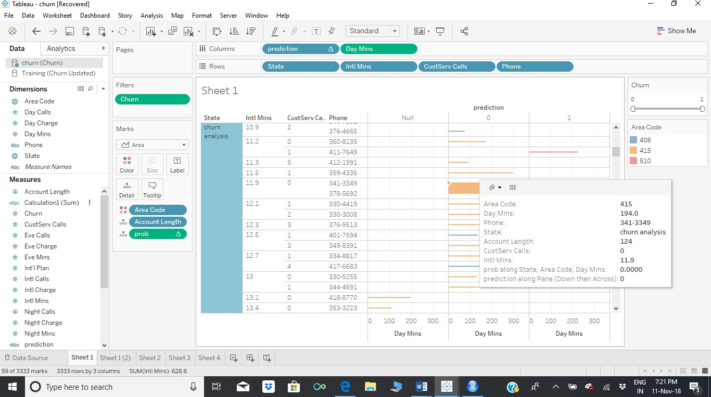

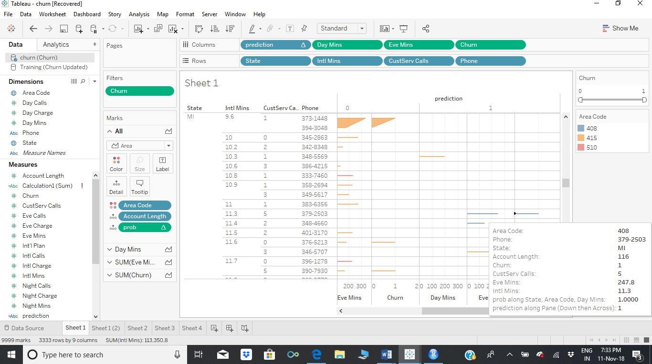

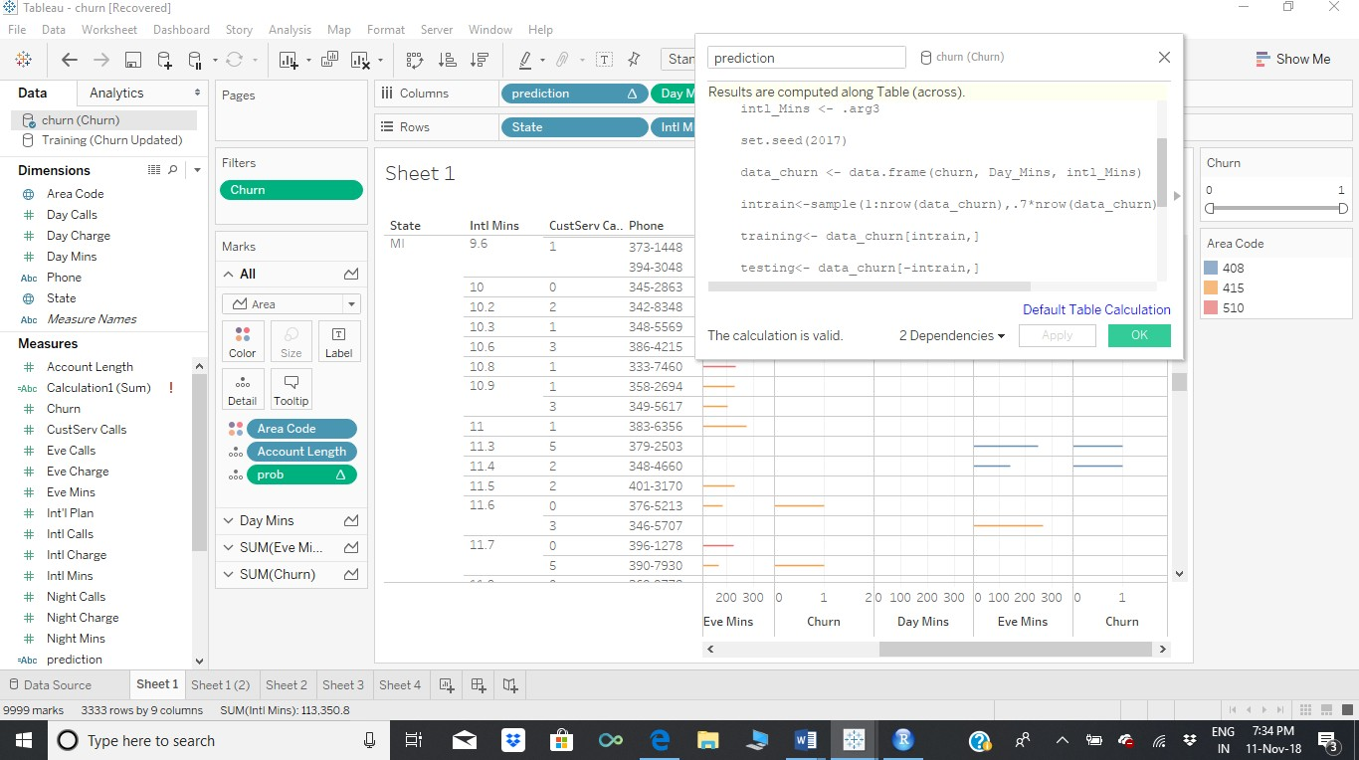

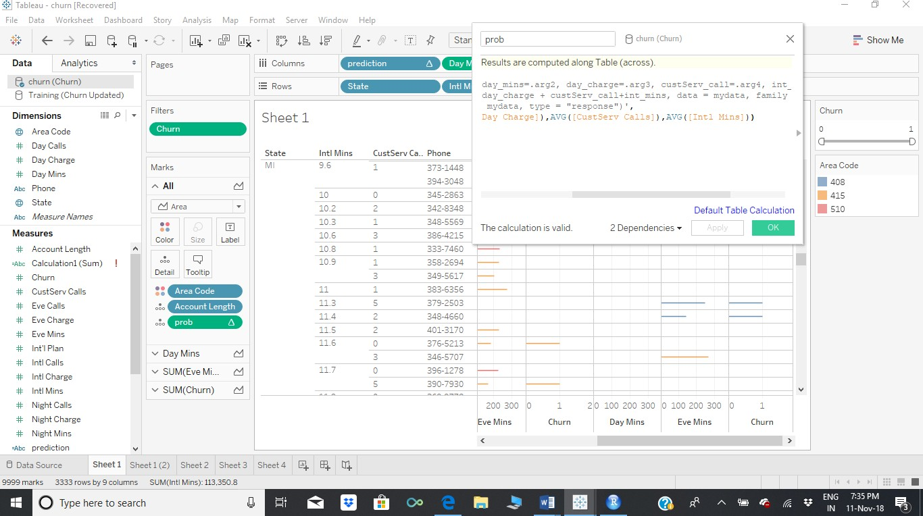

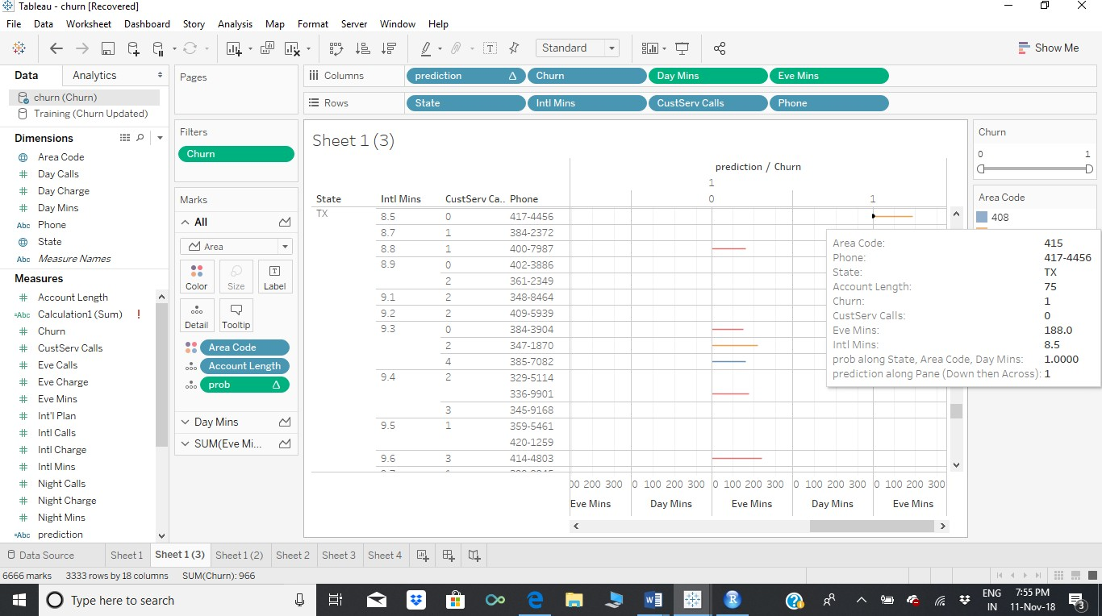

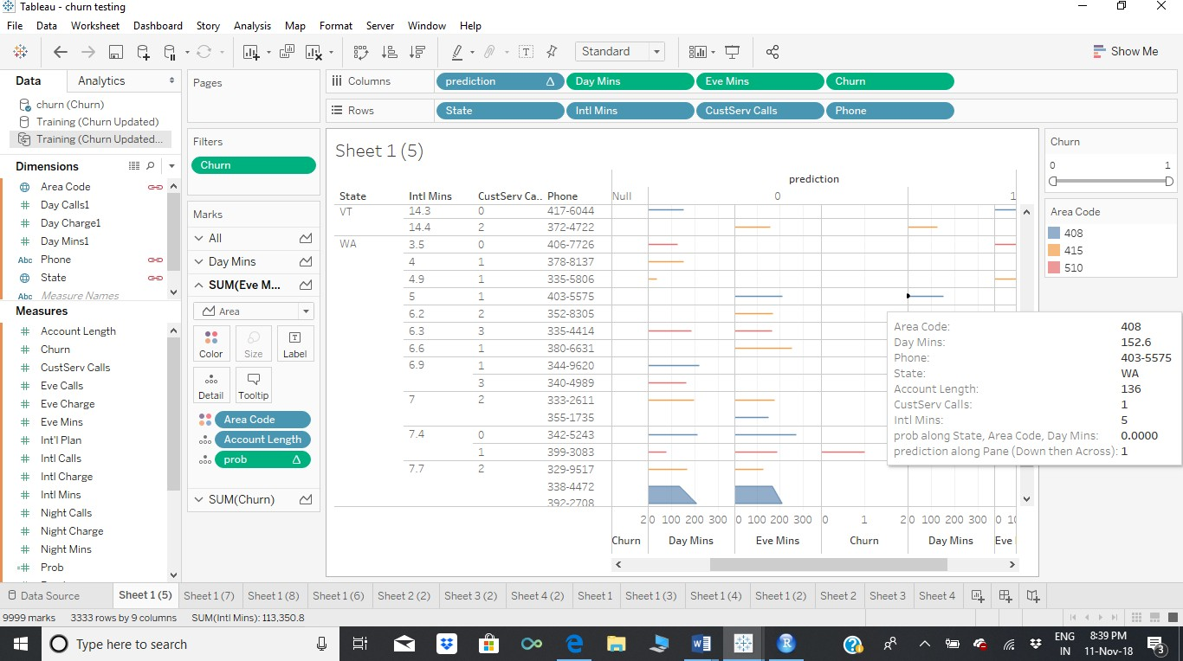

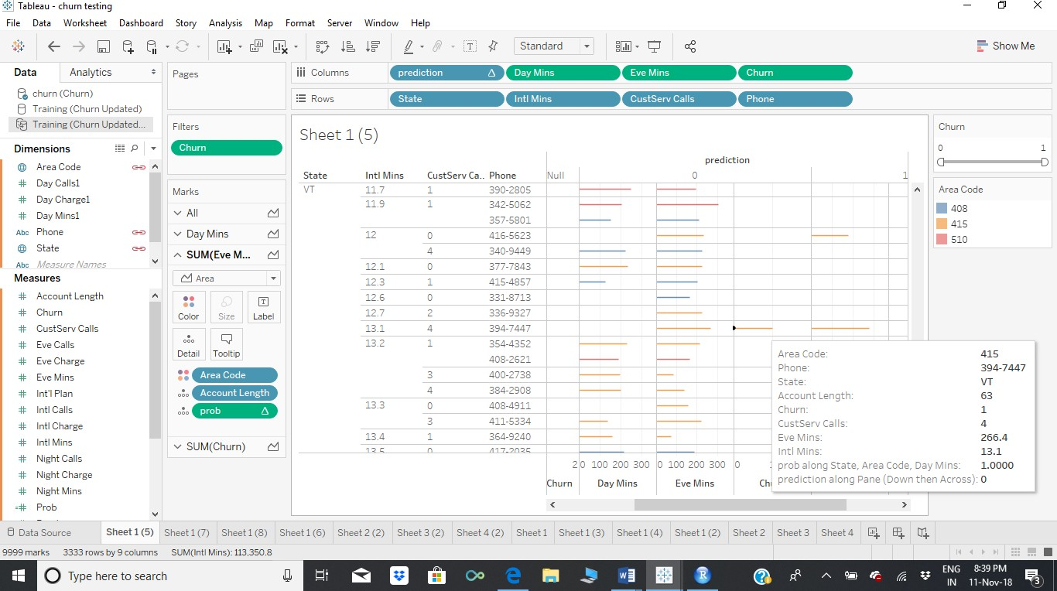

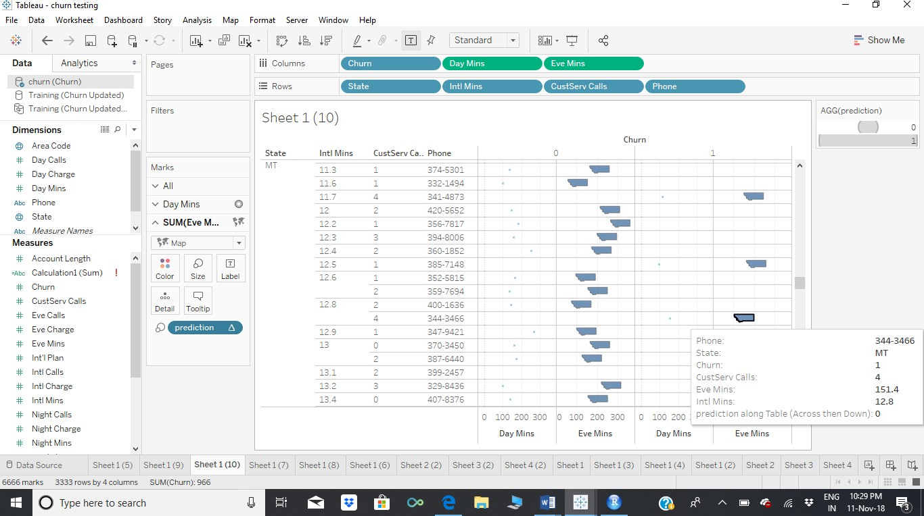



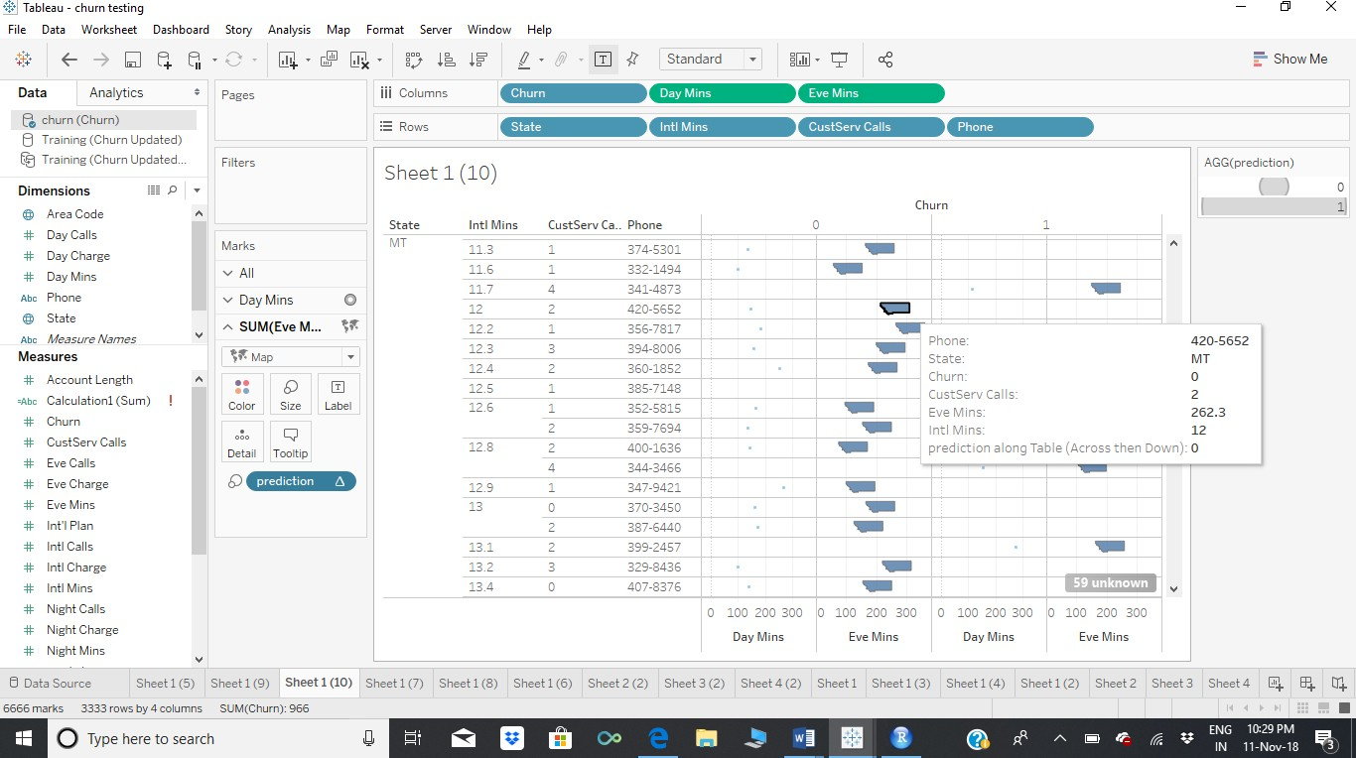

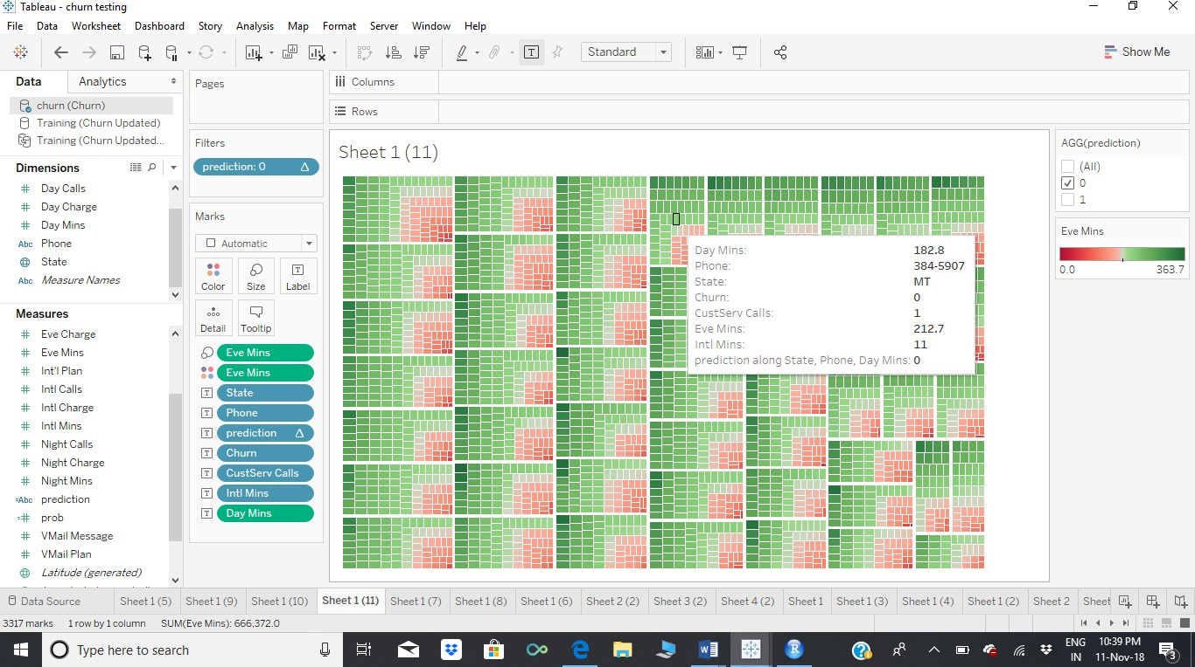

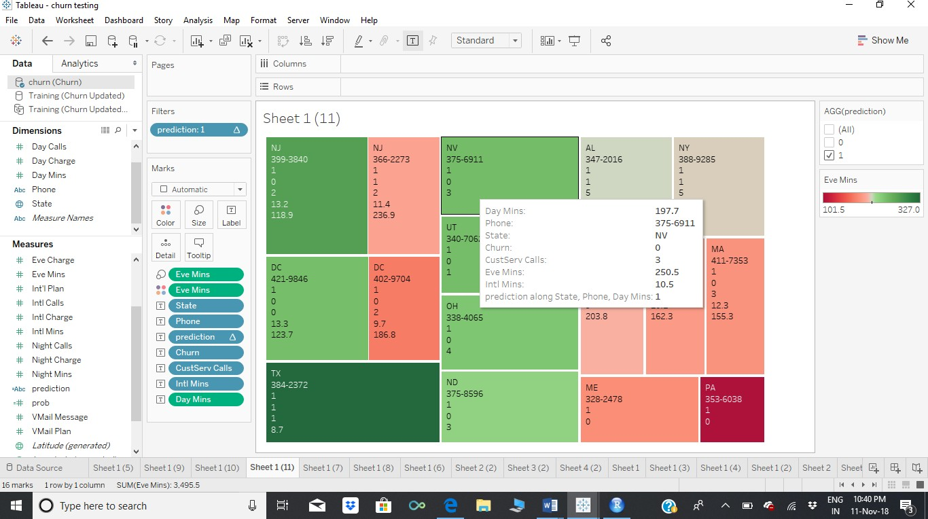

# Prediction in slider

we can select 0,1 or All

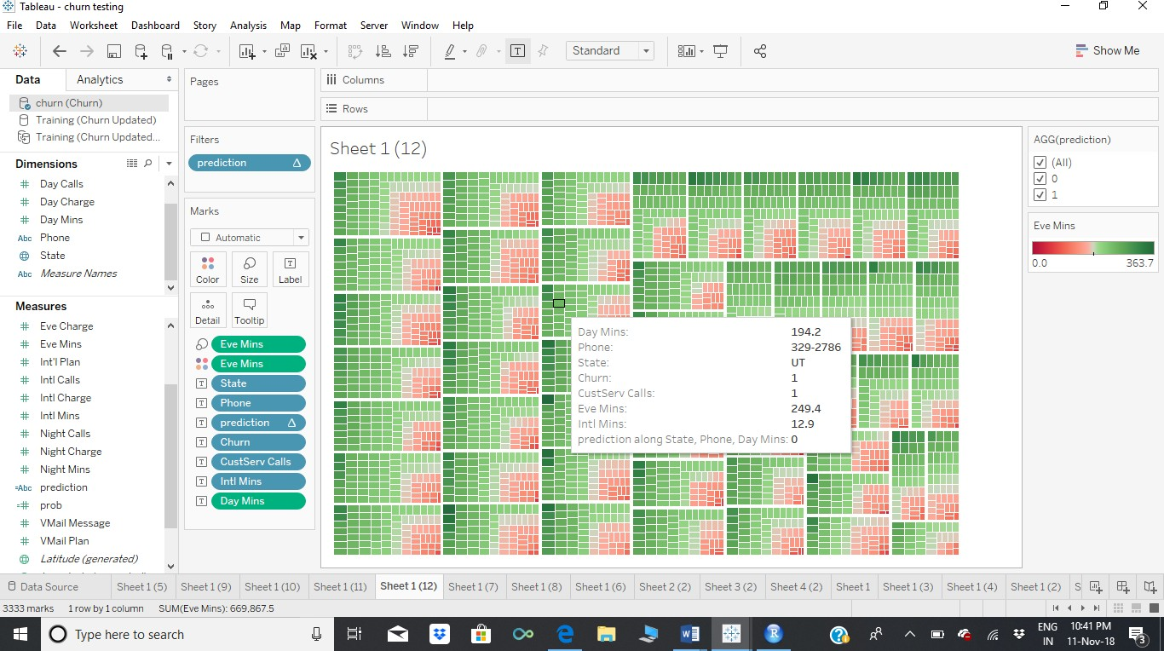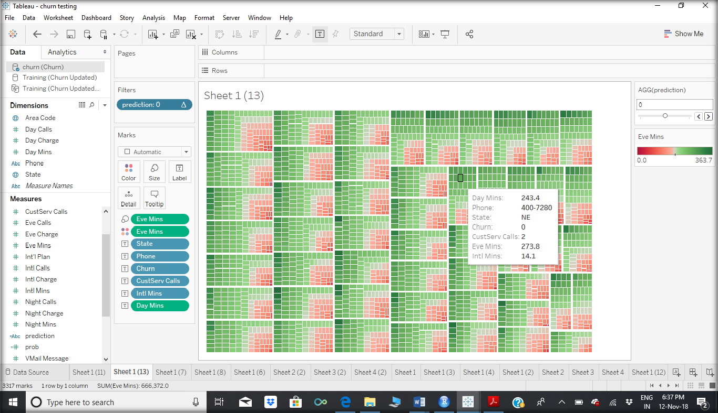

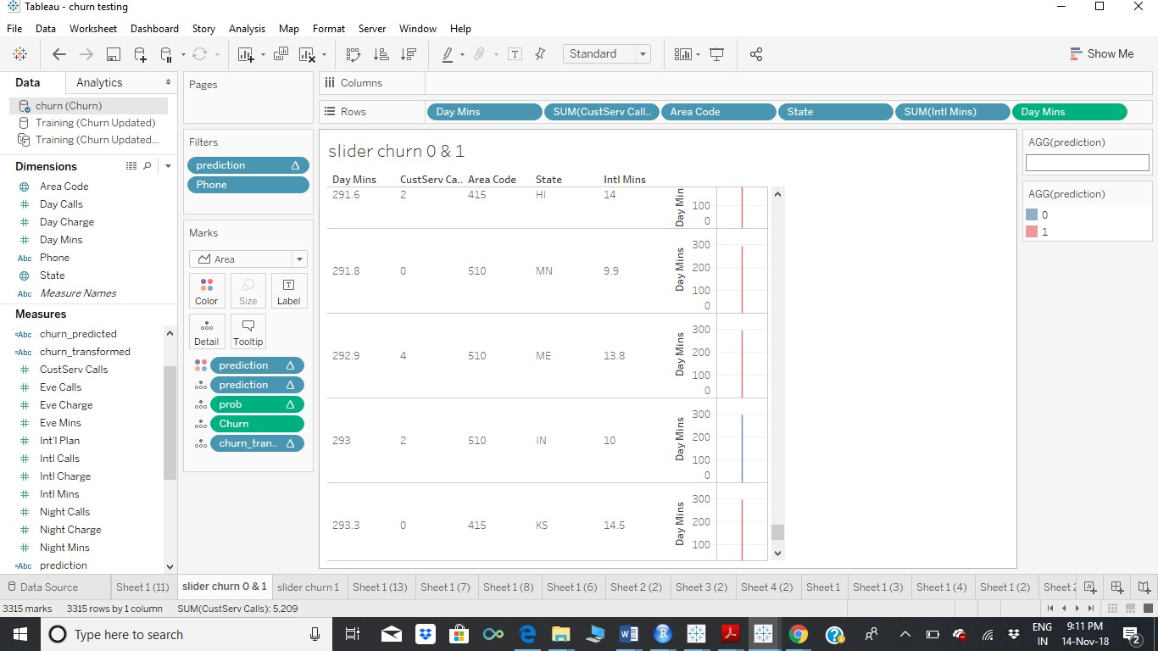

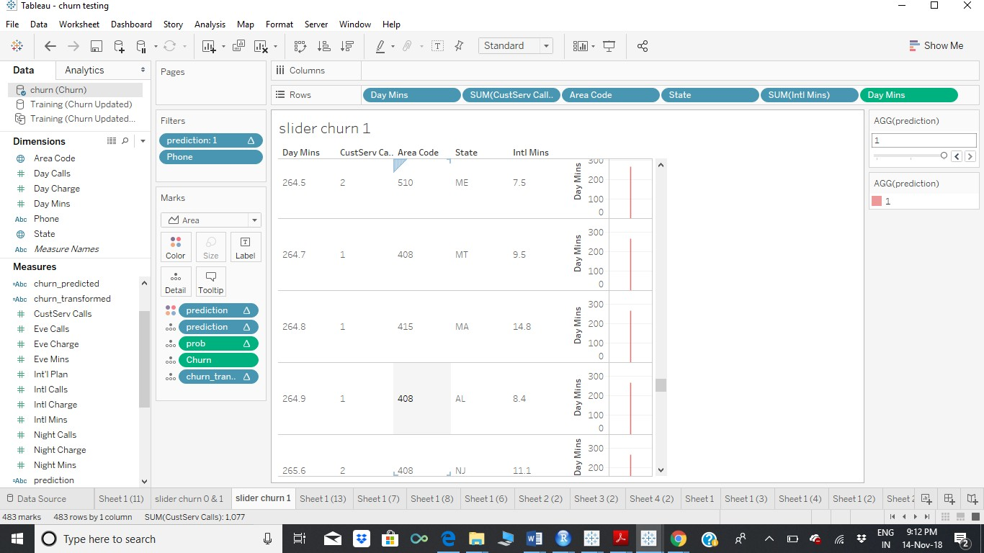

   

churn prediction.csv

churn all data.csv churn 0 data.csv All churn1 data.csv

## In this project a customer churn analysis was presented for churn data provided in the project 2. The analysis focused on churn prediction based on logistic regression. The different models predicted the actual churners relatively well.

The differences between the models input data (the significance level in case of each of the variables) indicates the dynamic nature of the churning customer profile. This makes it hard to formulate one standard model that could be used as the predictive model in the future. The findings of this study indicate that, in case of logistic regression model, the user should update the model to be able to produce predictions with high accuracy. It is interesting for a company’s perspective whether the churning customers are worth retaining or not. And also in marketing perspective what can be done to retain them. For Visualization Tableau desktop is used. Calculated fields is used to calculate the probability and the fitted results prediction. Using the Library Reserve in R Logistic regression model is connected with Tableau.

Through this model we can identify easily the churn 1 or 0 and the probabilities through a slider to visualize the churn 1, churn 0 and all. The visualization in Tableau provides separately state wise, Area code, specific telephone no and their probability to predict and visualize them nicely. The data can be imported and stored as excel data for further analysis and churn predictions. These files are exported and stored and attached in this project file.

Acknowledgement

This is a quite interesting project and I have gained a lot of knowledge. I thank the institute Acadgild and the Mentors Dr.Vinod and Miss Pooja who taught us the R coding and other subjects to understand the Algorithms. I thank the support coordinator for guiding me to understand the project related queries and complete the project on time.

Thank you Acadgild.